Cortana Intelligence Suite

Workshop Manual

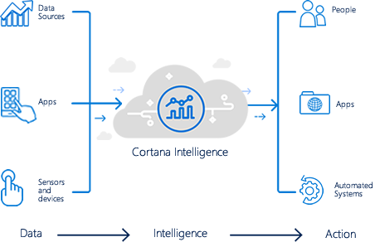

© 2017 Microsoft Corporation. All rights reserved. This document is confidential and proprietary to Microsoft. Internal use only. This document is for informational purposes only. MICROSOFT MAKES NO WARRANTIES, EXPRESS OR IMPLIED, IN THIS SUMMARY.

This document is provided "as-is." Information and views expressed in this document, including URL and other Internet Web site references, may change without notice. You bear the risk of using it.

Some examples are for illustration only and are fictitious. No real association is intended or inferred.

Table of Contents

Cortana Intelligence Lab Exercises 1

Overview 1

Exercise 0: Requirements 1

Exercise 1: Building a Machine Learning Model 2

Exercise 2: Setup Azure Data Factory 22

Exercise 3: Develop Data Factory Pipeline for Data Movement 27

Exercise 4: Operationalize ML Scoring with Azure ML and Data Factory 32

Exercise 5: Summarize Data Using HDInsight Spark 37

Exercise 6: Visualizing in Power BI Desktop 42

Exercise 7.1: Acquire Weather API Key 49

Exercise 7.2: Deploy Intelligent Web App 50

Exercise 8: Cleanup of Azure resources 52

Appendix A: Alternative to Azure ML Exercise 53

# Cortana Intelligence Lab Exercises

## Overview

AdventureWorks Travel (AWT) provides concierge services for business travelers. In an increasingly crowded market, they are always looking for ways to differentiate themselves and provide added value to their corporate customers.

They are looking to pilot a web-app that their internal customer service agents can use to provide additional information useful to the traveler during the flight booking process. They want to enable their agents to enter in the flight information and produce a prediction as to if the departing flight will encounter a 15 minute or longer delay, taking into account the weather forecasted for the departure hour.

In this lab, attendees will build an end-to-end solution to predict flight delays taking into account the weather forecast.

## Exercise 0: Requirements

* Microsoft Azure Subscription should be pay-as-you-go, MSDN, or EA.
  + Recommendation is to have each user have their own Azure subscription; this will allow every attendee to have their own sandbox.
* Setup is required before performing the steps in these exercises. Please see [**http://bit.ly/2pAsC4n**](http://bit.ly/2pAsC4n) before going any further.
* Please keep in mind that HDInsight cluster and VM you provision as setup for this workshop **will incur charges$$**, so **provision these resources** closest to the workshop date as possible. Preferably **15 minutes before the workshop**.

## Exercise 1: Building a Machine Learning Model

Duration: 60 mins

Synopsis: In this exercise, attendees will implement a classification experiment. They will load the training data from their local machine into a dataset. Then they will explore the data to identify the primary components they should use for prediction, and use two different algorithms for predicting the classification. They will evaluate the performance of both and algorithms choose the algorithm that performs best. The model selected will be exposed as a web service that is integrated with the sample web app.

### **Task 1: Log in to the Lab VM**

1. From the left side of the Azure portal, click on **Browse >.**
2. In the **filter** box, type in **virtual.**
3. Click on **Virtual Machine**.

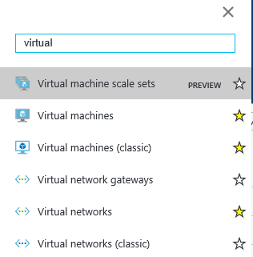

1. Keep in mind the name of the virtual machine will be the “APPNAME” you provided when setting up this workshop environment.
2. Click on the **<YOUR_APP_NAME>lab** virtual machine from the list and click on **Connect**.

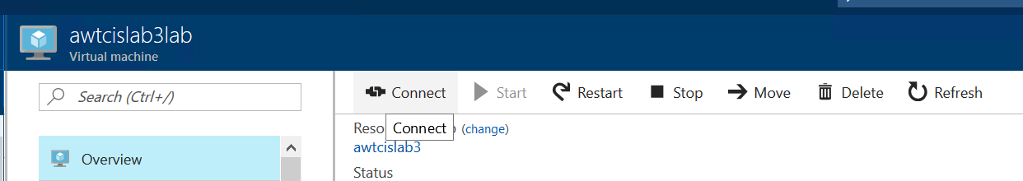

1. Download and open the RDP file.
2. When Remote Desktop Connection screen appear, check the box **Don’t ask…** and click on **Connect** button.

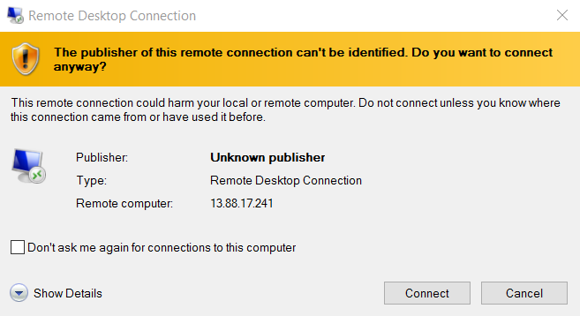

1. Log in with the credentials you specified for the Lab VM during the deployment of the workshop prerequisites.

### **Task 2: Navigate to Machine Learning Studio**

1. Inside the Virtual Machine, open a new browser and go to <https://studio.azureml.net>. Sign in using the same account you used in the Azure portal to deploy the prerequisites for this workshop.
2. Once you are signed in, ensure the workspace that was created as part of the prerequisites is selected from the top bar.

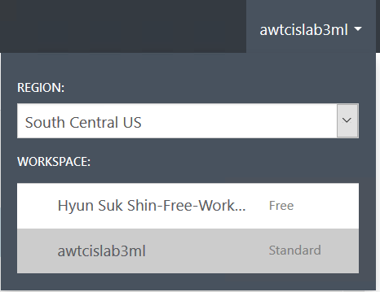

### **Task 3: Upload the Sample Datasets (Ingest Data)**

1. Before you begin creating a machine learning experiment, there are two datasets you need to load. Those two datasets are already downloaded to your VM.
2. From the Machine Learning Studio, click **+ NEW** at the bottom, point to **Dataset**, and select **From Local File**.

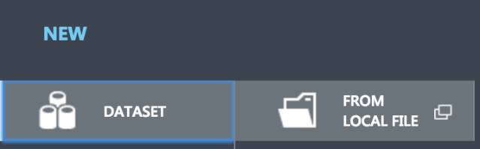

1. In the dialog that appears, click **Choose File** and browse to the "**C:\data\1.MachineLearning\awt_flightsandweather.csv**" file and click **OK**.
2. By removing file extension, change the name of the dataset to “**awt_flightsandweather**”.
3. Click on the  Check Mark from the bottom right corner of the screen.

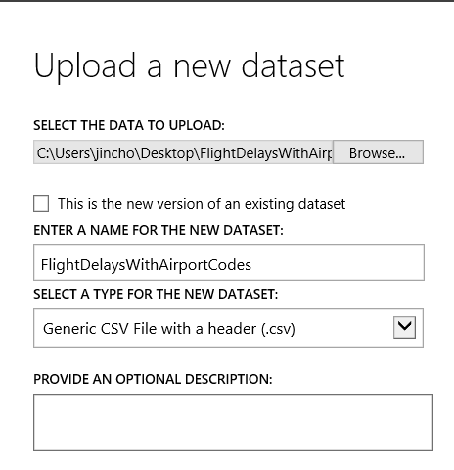

1. Upload one more file. Click **+ NEW** at the bottom, point to **Dataset**, and select **From Local File**.



1. In the dialog that appears, click **Choose File** and browse to the "**C:\data\1.MachineLearning\airportlocations.csv**" file and click **OK**.
2. By removing file extension, change the name of the dataset to “**airportlocations**”.
3. Click on the  check Mark from the bottom right corner of the screen.

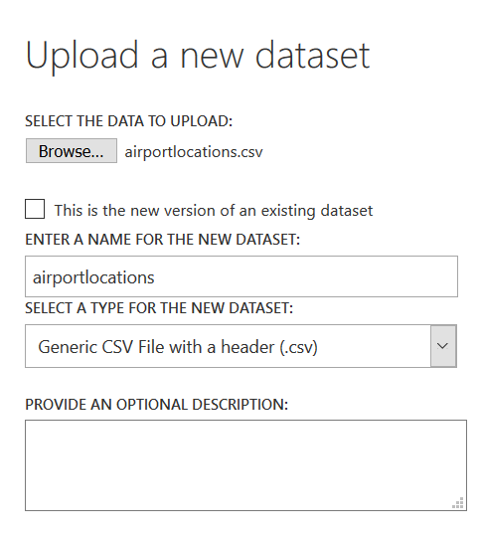

### **Task 4: Start a new experiment**

1. Click **+ NEW** in the command bar.
2. In the options that appear, click **Blank Experiment**.

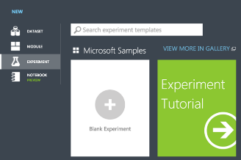

1. Give your new experiment a name, such as “**AdventureWorks Travel”** by editing the label near the top of the design surface.

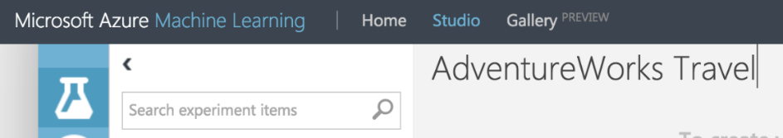

1. In the toolbar on the left, in the Search experiment items box, type the name of the dataset you created with flight delay data (awt_flightsandweather). You should see a component for it listed under Saved Datasets, My Datasets.

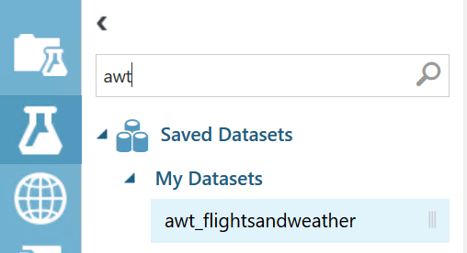

1. Click and drag on the “awt_flightsandweather” to add it to the canvas.

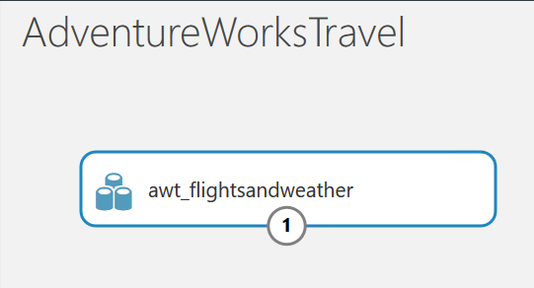

1. Next, you will explore each of the datasets to understand what kind of cleanup (aka data munging) will be necessary.

### **Task 5: Explore the data**

1. Hover over the output port of the “awt_flightsandweather” dataset.

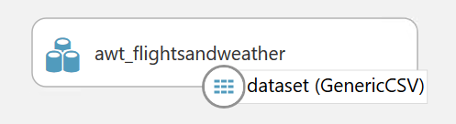

1. Right-click on the port and select **Visualize**.

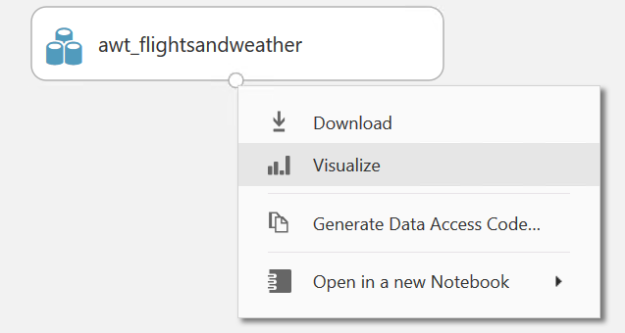

1. A new dialog will appear showing a maximum of 100 rows by 100 columns sample of the dataset. You can see at the top that the dataset has a total of 2,905,200 rows (also referred to as examples in Machine Learning literature) and has 11 columns (also referred to as features).

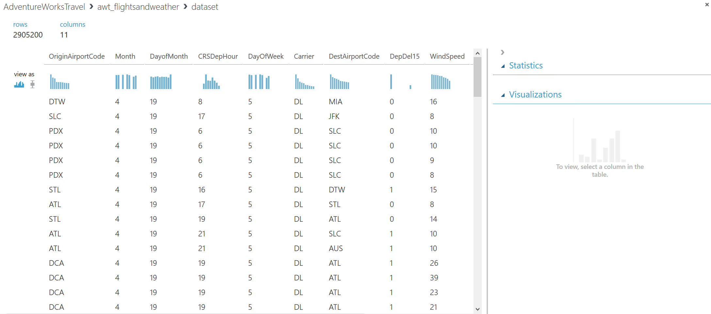

1. Because all 11 columns are displayed, you can scroll the grid horizontally. Scroll until you see the **DepDelay15** column and click it to view statistics about the column. The DepDelay15 column displays a 1 when the flight was delayed at least 15 minutes and 0 if there was no such delay. In the model you will construct, you will try to predict the value of this column for future data.

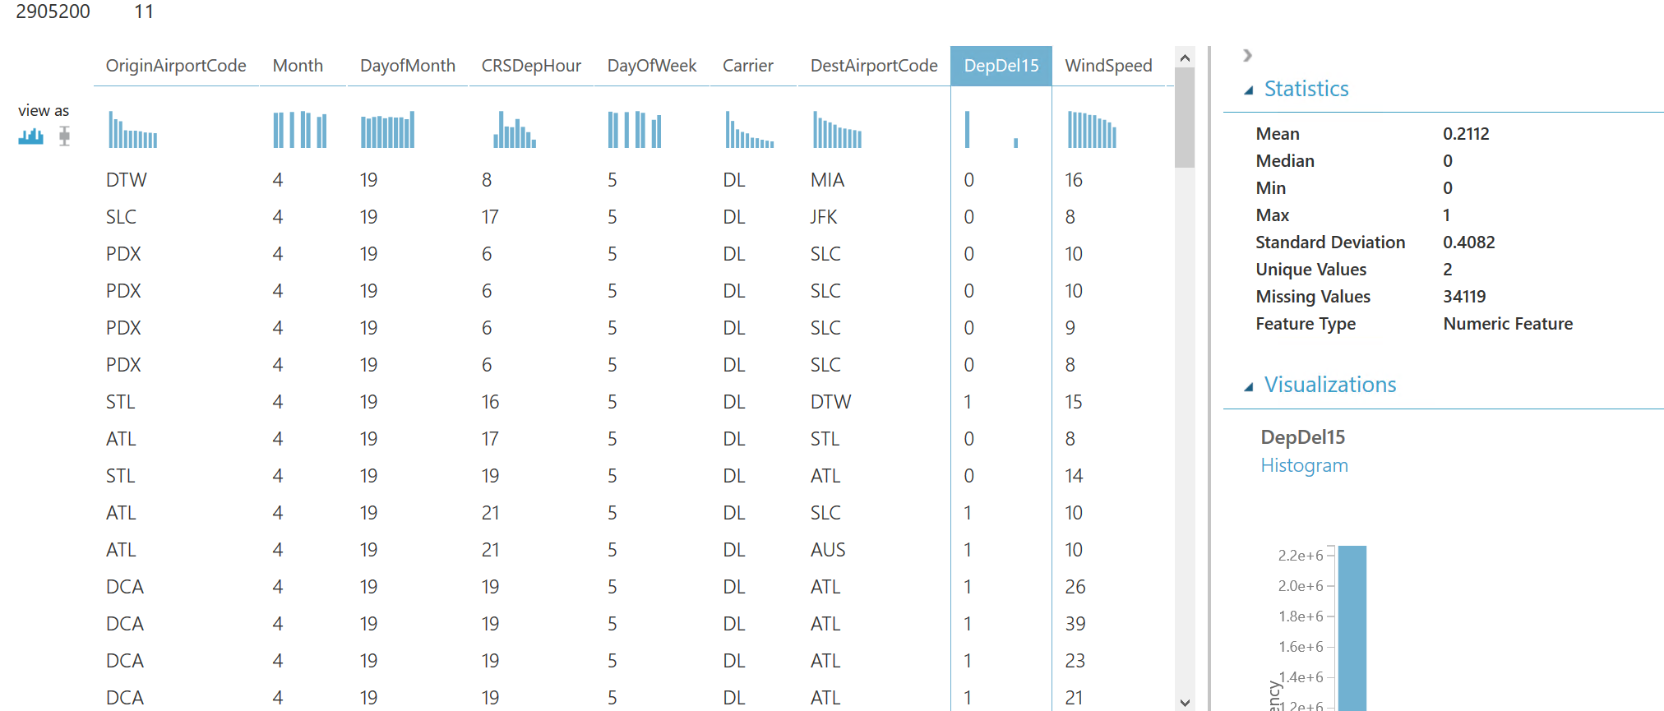

1. Notice in the Statistics panel on right top corner shows that 34,119 values of DepDel15 are missing. This means that 34,119 rows do not have a value in this column. Since this value is very important to our model, we will eliminate any rows that do not have a value for this column during the workshop.
2. Let’s look another column. In the dialog, click the **WindSpeed** column and review the statistics. Observe that the Feature Type is inferred as String and there are 110 Missing Values. Below that, examine the histogram to see that, even though the type is inferred as String, the values are all numbers (e.g. the x-axis values are 0, 6, 5, 7, 3, 8, 9, 10, 11, 13). We will remove any missing values and convert WindSpeed to its proper type as a Numeric feature.

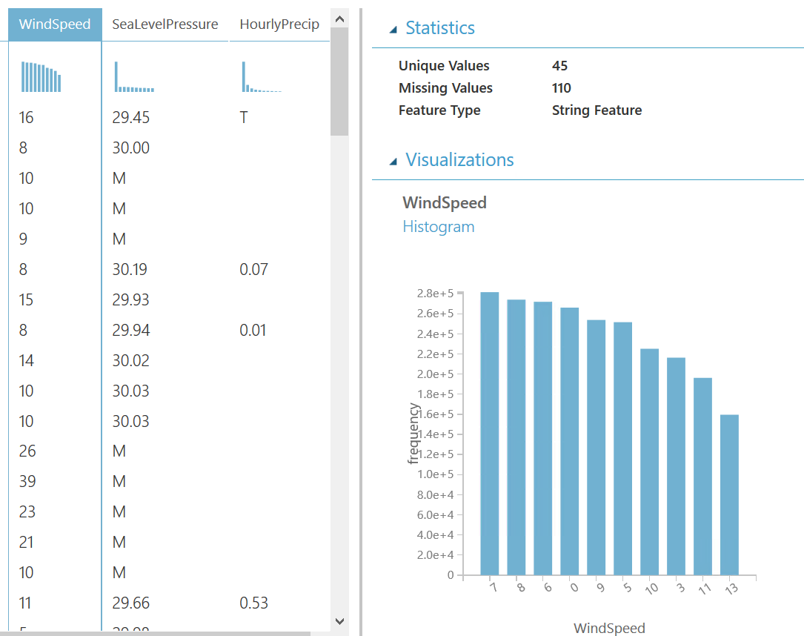

1. Let’s look another column. Click the **SeaLevelPressure** column. Observe that the Feature Type is inferred as String and there are 0 Missing Values. Scroll down to the histogram, and observe that many of the features of a numeric value (e.g., 29.96, 30.01, etc.), but there are many features with the string value of M for Missing. We will need to replace this value of “M” with a suitable numeric value so that we can convert this feature to be a Numeric feature.

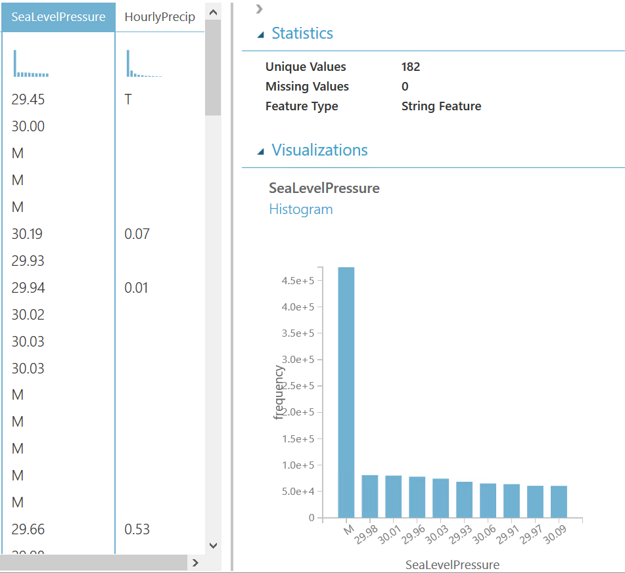

1. Finally, examine the **HourlyPrecip** feature. Observe that it too was inferred to have a Feature Type of String and is missing values for 2,664,466 rows. Looking at the histogram, observe that besides the numeric values, there is a value “T” for Trace amount of rain. We will need to replace the “T” with a suitable numeric value and covert this feature to a Numeric feature.

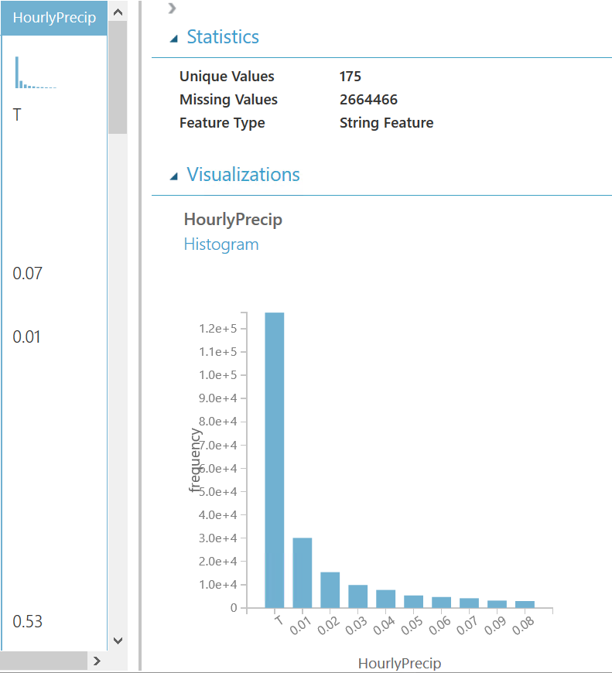

### **Task 6: Prepare data**

1. Let’s begin data preparation by cleaning up the missing values for DepDelay,15 WindSpeed and HourlyPrecip.
2. Add an **Execute R Script** module beneath the “awt_flightsandweather” dataset and connect the output of the dataset to the first input port (leftmost) of the **Execute R Script**.

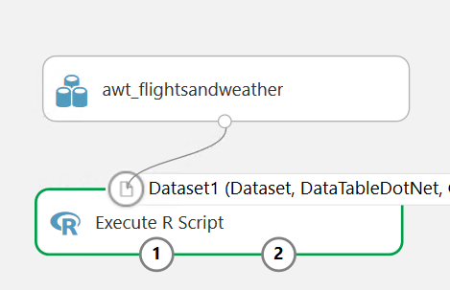

1. In the **Properties** panel for **Execute R Script**, click the "double window" icon to maximize the script editor.

[](https://github.com/toddkitta/CortanaIntelligenceSuiteWorkshopManual/blob/master/images/start_a_new_experiment_27.png)

1. Replace the default script with the following and click the checkmark to save it. Following code also can be found <http://bit.ly/2xORsSE>.

|  |
| --- |
| # AWT Flights and Weather dataset  # Task 4: Understand Data  # Map 1-based optional input ports to variables  ds.awtdata <- maml.mapInputPort(1)  # Remove rows with missing values in DepDel15  ds.awtdata <- ds.awtdata[!is.na(ds.awtdata$DepDel15), ]  # substitute missing values in HourlyPrecip & WindSpeed  ds.awtdata$HourlyPrecip[is.na(ds.awtdata$HourlyPrecip)] <- 0.0  ds.awtdata$WindSpeed[is.na(ds.awtdata$WindSpeed)] <- 0.0  # Replace any WindSpeed values of "M" with 0.005 and make the feature numeric  speed.num = ds.awtdata$WindSpeed  speed.num[speed.num == "M"] = 0.005  speed.num = as.numeric(speed.num)  ds.awtdata$WindSpeed = speed.num  # Replace any SeaLevelPressure values of "M" with 29.92 (the average pressure) and make the feature numeric  pressure.num = ds.awtdata$SeaLevelPressure  pressure.num[pressure.num == "M"] = 29.92  pressure.num = as.numeric(pressure.num)  ds.awtdata$SeaLevelPressure = pressure.num  # Adjust the HourlyPrecip variable (convert "T" (trace) to 0.005)  rain = ds.awtdata$HourlyPrecip  rain[rain %in% c("T")] = "0.005"  ds.awtdata$HourlyPrecip = as.numeric(rain)  # cast some of the data types to factor (categorical)  ds.awtdata$OriginAirportCode <- as.factor(ds.awtdata$OriginAirportCode)  # cast some of the data types to factor (categorical)  ds.awtdata$DayOfWeek <- as.factor(ds.awtdata$DayOfWeek)  ds.awtdata$Carrier <- as.factor(ds.awtdata$Carrier)  ds.awtdata$DestAirportCode <- as.factor(ds.awtdata$DestAirportCode)  ds.awtdata$OriginAirportCode <- as.factor(ds.awtdata$OriginAirportCode)  maml.mapOutputPort("ds.awtdata"); |

1. **Run** the experiment to update the metadata and process the data (this may take a minute or two to complete).

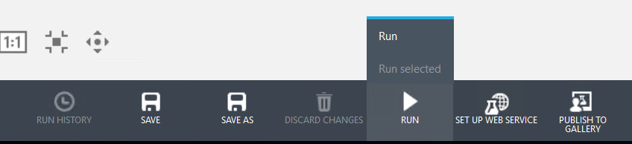

1. Right click on the leftmost output port of your **Execute R Script** module and select **Visualize**.

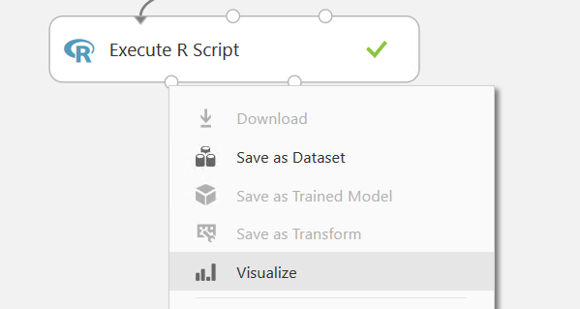

1. Compare the data in this view with the data before it was processed by the R script (refer Task #5). Verify that the dataset only contains the 11 columns and 2,871,081 rows. Also verify that **DepDel15**, **WindSpeed**, **SeaLevelPressure**, and **HourlyPrecip** are now all Numeric Feature types and that they have no missing values.

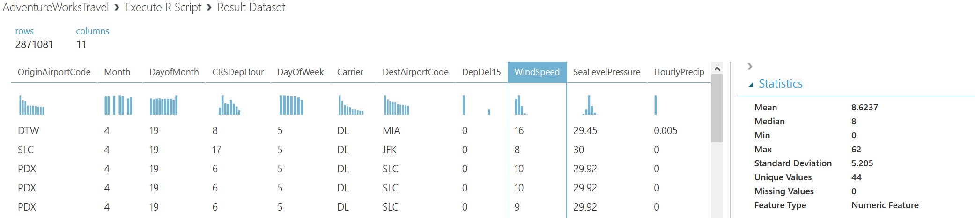

### **Task 6: Build a model**

AdventureWorks Travel wants to **build a model to predict if a departing flight will have a 15-minute or greater delay.** In the historical data we have, the indicator for such a delay is found within the DepDelay15 (where a value of 1 means delay more than 15 minutes, 0 means no delay or less than 15 minutes). To create model that predicts such a binary outcome, we can choose from the various Two-Class modules that Azure ML offers. For our purposes, we begin with a Two-Class Logistic Regression. This type of classification module needs to be first trained on sample data that includes the features important to making a prediction and must also include the actual historical outcome for those features.

The typical pattern is split the historical data so a portion is shown to the model for training purposes, and another portion is reserved to test just how well the trained model performs against examples it has not seen before.

1. Drag a **Split Data** module beneath **Execute R Script** and connect them.

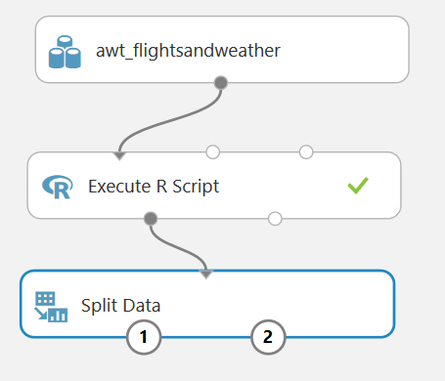

1. On the **Properties** panel for the Split Data module, set the Fraction of rows in the first output dataset to **0.7** (so 70% of the historical data will flow to output port 1). Set the Random seed to **7634**.

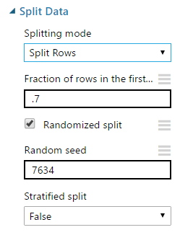

1. Next, add a **Train Model** module and connect it to lift output port of the **Split Data** module.

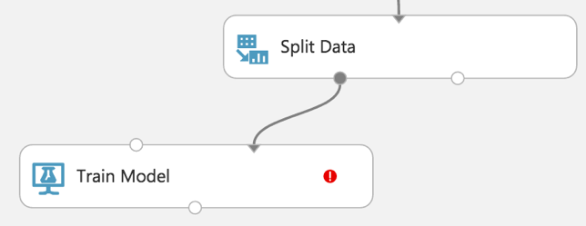

1. On the **Properties** panel for the Train Model module, set the Selected columns to **DepDelay15**.

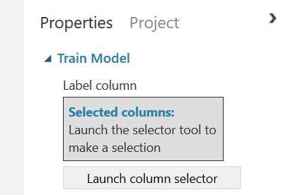

1. Drag a **Two-Class Logistic Regression** module above and to the left of the Train Model module and connect the output to the leftmost input of the Train Model module

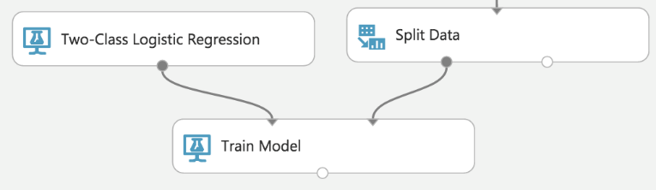

1. Below the Train Model drop a **Score Model** module. Connect the output of the Train Model module to the leftmost input port of the Score Model and connect the rightmost output of the Split Data module to the rightmost input of the Score Model.

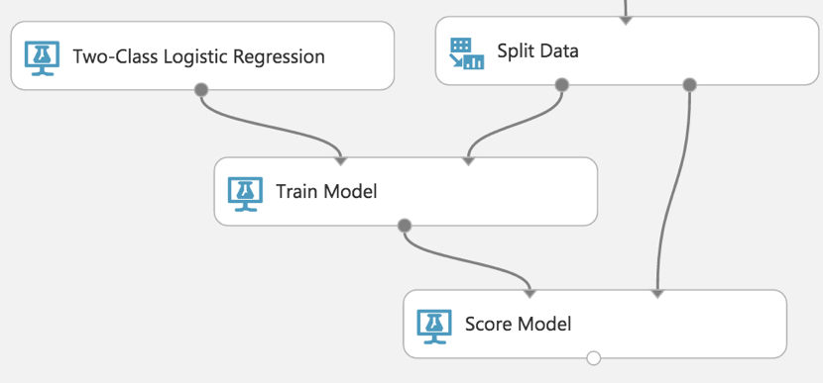

1. **Run** the experiment.
2. When the experiment is finished running (which takes a few minutes), right-click on the output port of the Score Model module and select **Visualize** to see the results of its predictions. You should have a total of 13 columns. The original columns was 11.

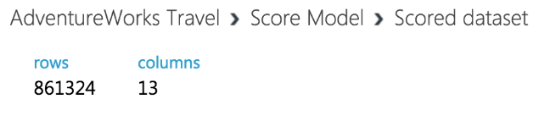

|  |  |
| --- | --- |
| 1. If you scroll to the right so that you can see the last two columns, observe there is a **Scored Labels** column and a **Scored Probabilities** column. The former is the prediction (1 for predicting delay, 0 for predicting no delay) and the latter is the probability of the prediction. In the screenshot on right, for example, the last row shows a delay predication with a 53.1% probability. | [Screenshot](https://github.com/toddkitta/CortanaIntelligenceSuiteWorkshopManual/blob/master/images/train_the_model_7.png) |

1. While this view enables you to see the prediction results for the first 100 rows, if you want to get more detailed statistics across the prediction results to evaluate your model’s performance you can use the Evaluate Model module.
2. Drag an **Evaluate Model** module on to the design surface beneath the Score Model module. Connect the output of the Score Model module to the leftmost input of the Evaluate Model module.

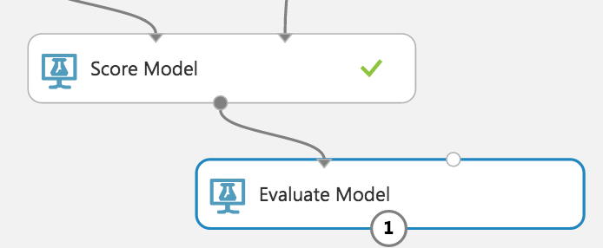

1. **Run** the experiment.
2. When the experiment is finished running, right-click the output of the Evaluate Model module and select **Visualize**. In this dialog box, you are presented with various ways to understand how your model is performing in the aggregate. While we will not cover how to interpret these results in detail, we can examine the ROC chart that tells us that at least our model (the blue curve) is performing better than random (the light gray straight line going from 0,0 to 1,1)—which is a good start for our first model!

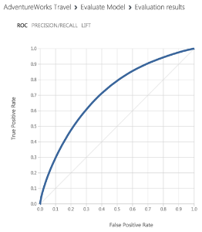

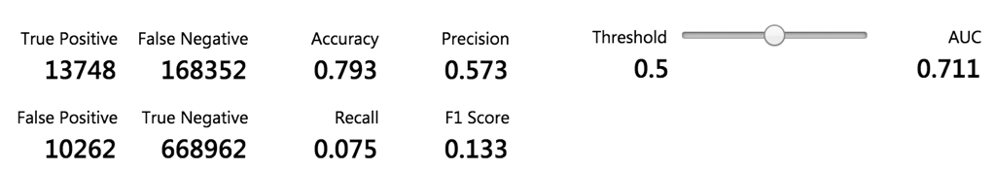

### **Task 7: Operationalize the experiment**

1. Now that we have a functioning model, let us package it up into a predictive experiment that can be called as web service.
2. In the command bar at the bottom, click **Set Up Web Service** and then select **Predictive Web Service**. If you see that the **Set Up Web Service** option is grayed out, then you may need to run the experiment again by click on the **RUN** button.

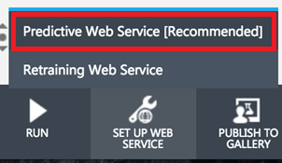

1. A copy of your training experiment is created that contains the trained model wrapped between web service input (e.g. the web service action you invoke with parameters) and web service output modules (e.g., how the result of scoring the parameters are returned).
2. Right click on the line that connects the new **Web service input** module to the **Execute R Script** module and click **Delete**.
3. Now move the **Web service input** side so, it is to the right of the **awt_flightsandweather** data set.

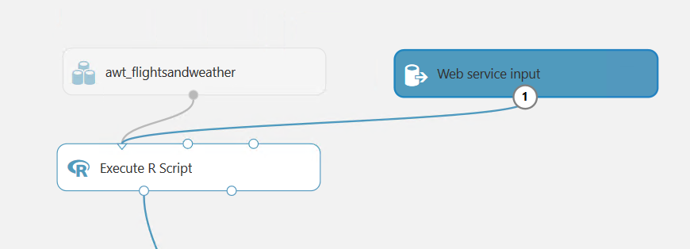

1. Right click the blue line connecting the **Execute R Script** module and **Score Model** module, select **Delete**. Move the **Execute R Script** module up a little to give yourself a more room between those two modules.

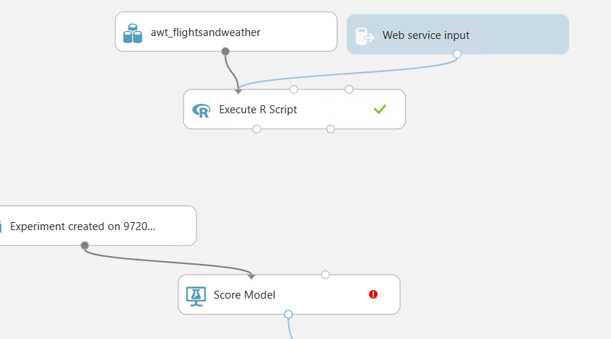

1. Between the **Execute R Script** modules and **Score Model** modules, drop a **Select Columns in Dataset** module

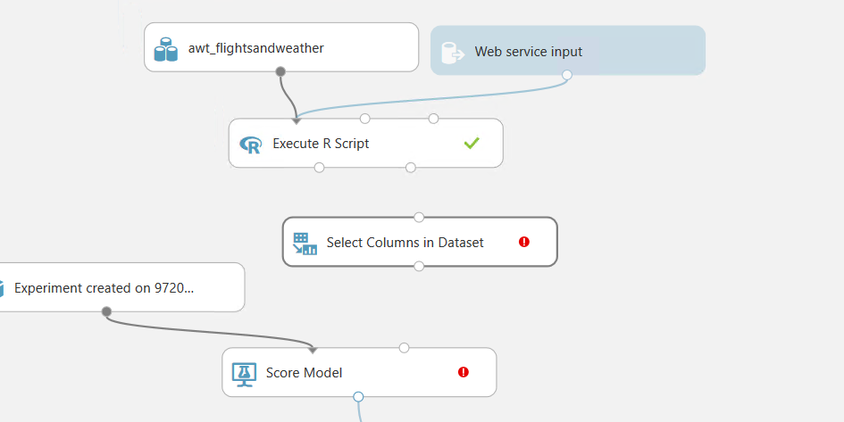

1. Connect **Execute R Script** to this new **Select Columns in Dataset** module. And connect **Select Columns in Dataset** module and **Score Model** module.

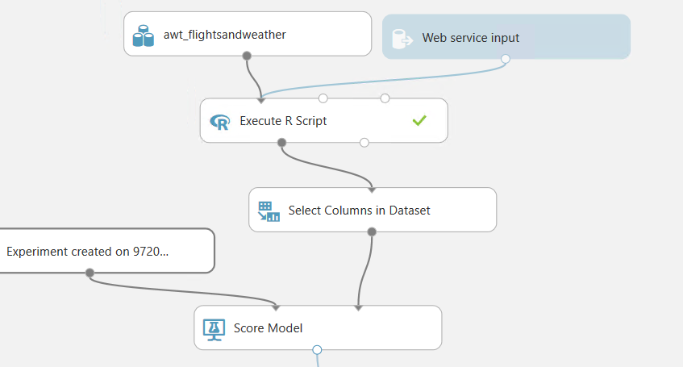

1. In the **Properties** panel for the **Select Columns in Dataset** module click the **Launch column selector** button. In this dialog, click **ALL COLUMNS** and select **Exclude** (notice this is an exclude operation) from the dropdown box. Then select **DepDel15** in the textbox. This configuration will update the web service metadata so that this column does not appear as a required input parameter for the web service.

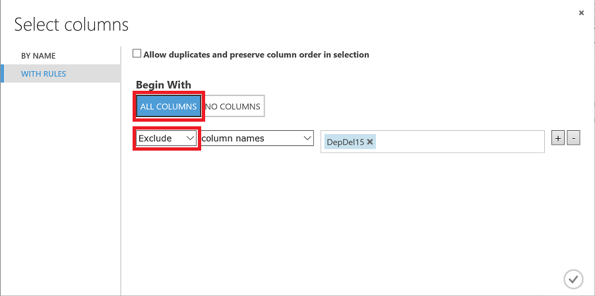

1. A part where getting parameters from an application should be updated as well. By making a connection between **Web service input** module to **Score Model** module, the machine learning will expect specific parameters from an application.

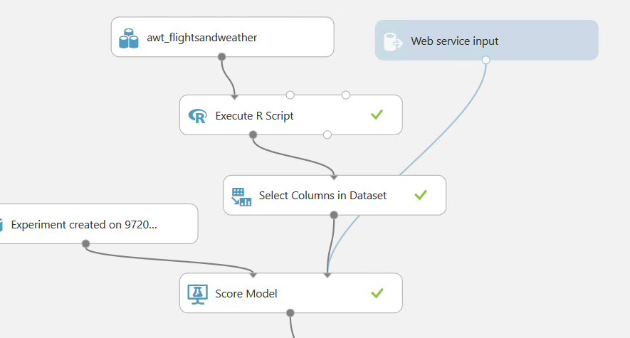

1. Because we have removed the latitude and longitude columns from the original dataset (so they were not required as an input to the web service), we have to add them back in before we return the result to an application so that the results can be easily visualized on a map.
2. To add these fields back, begin by deleting the line between the **Score Model** and **Web service output**. Right click the blue line connecting the **Score Model** module and Web service output module, select **Delete**.

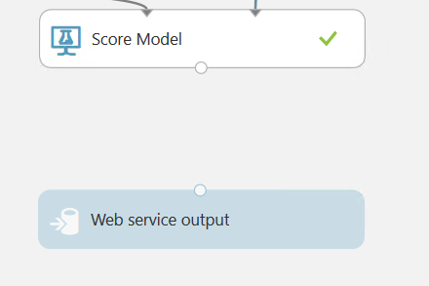

1. Drag the **AirportLocations** dataset on to the design surface, positioning it next to the Score Model module.

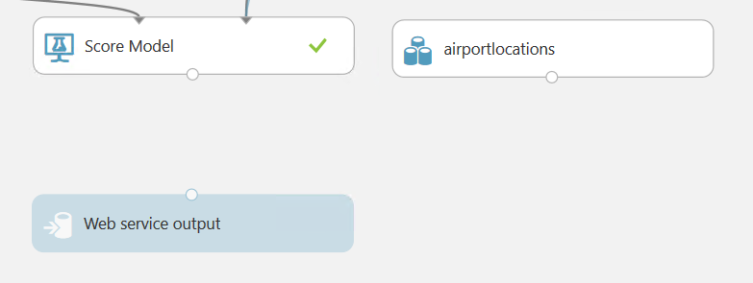

1. Add a **Join Data** module. Connect the output of the **Score Model** module to the leftmost input of the **Join Data** module and the output of the dataset to the rightmost input of the **Join Data** module.

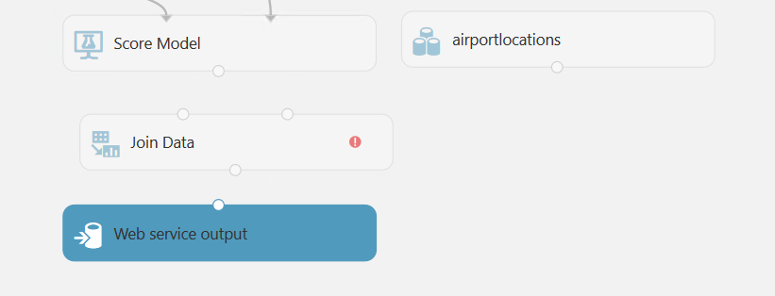

|  |  |
| --- | --- |
| 1. In the **Properties** panel for the **Join Data** module, for the **Join key columns for L** propery, set the selected columns to **OriginAirportCode**. For the **Join key columns for R** property, set the selected columns to **AIRPORT**. Uncheck Keep right key columns in joined table. | [Screenshot](https://github.com/toddkitta/CortanaIntelligenceSuiteWorkshopManual/blob/master/images/operationalize_the_experiment_12.png) |

1. Add an **Execute R Script** module beneath the **Join Data** module. Connect the **Join Data** output to the leftmost input of the **Execute R Script** module.

[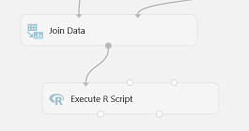](https://github.com/toddkitta/CortanaIntelligenceSuiteWorkshopManual/blob/master/images/operationalize_the_experiment_13.png)

1. Replace the default script in the **Execute R Script** module with the following and click the checkmark to save it. This script removes columns we don't need and renames others. Following code also can be found <http://bit.ly/2eGHsm4>.

|  |
| --- |
| ds.theresults <- maml.mapInputPort(1)  # remove a couple columns  ds.theresults$AIRPORT_ID <- NULL  ds.theresults$DISPLAY_AIRPORT_NAME <- NULL  # rename a couple columns  colnames(ds.theresults)[colnames(ds.theresults) == 'LATITUDE'] <- 'OriginLatitude'  colnames(ds.theresults)[colnames(ds.theresults) == 'LONGITUDE'] <- 'OriginLongitude'  maml.mapOutputPort("ds.theresults"); |

1. Connect the leftmost output of the **Execute R Script** module to the input of the **Web service output** module.

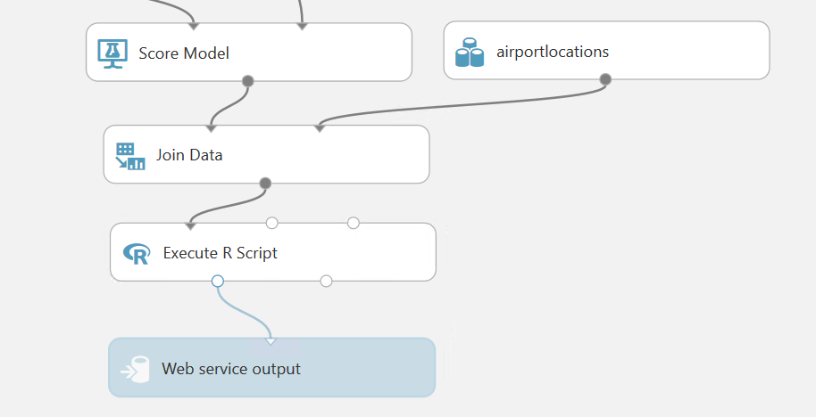

1. Finally, you will see flows like following.

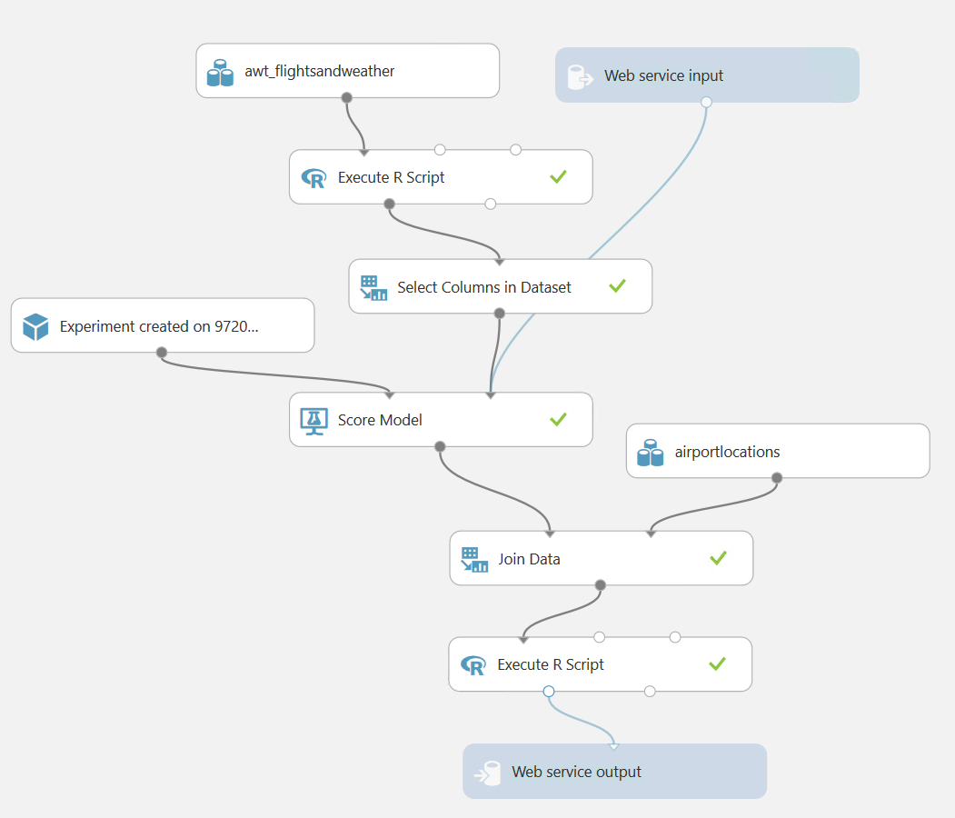

1. **Run** the experiment. This may take a few minutes. Your experiment is now ready to be deployed as a web service.

### **Task 8: Deploy Web Service and Note API Information**

1. When the experiment is finished running, click **Deploy Web Service [New]** (*not* [Classic]). This will launch the web service deployment wizard.

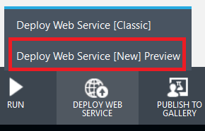

1. You can leave the default name, select **Create new...** for **Price Plan** and then provide a **Plan Name** value. Finally, under **Monthly Plan Options** select **Standard DevTest**.
   1. **NOTE:**: If you have already created a DevTest plan, you will not be able to create another one. You can simply select the DevTest plan that was already created from the **Price Plan** dropdown box.

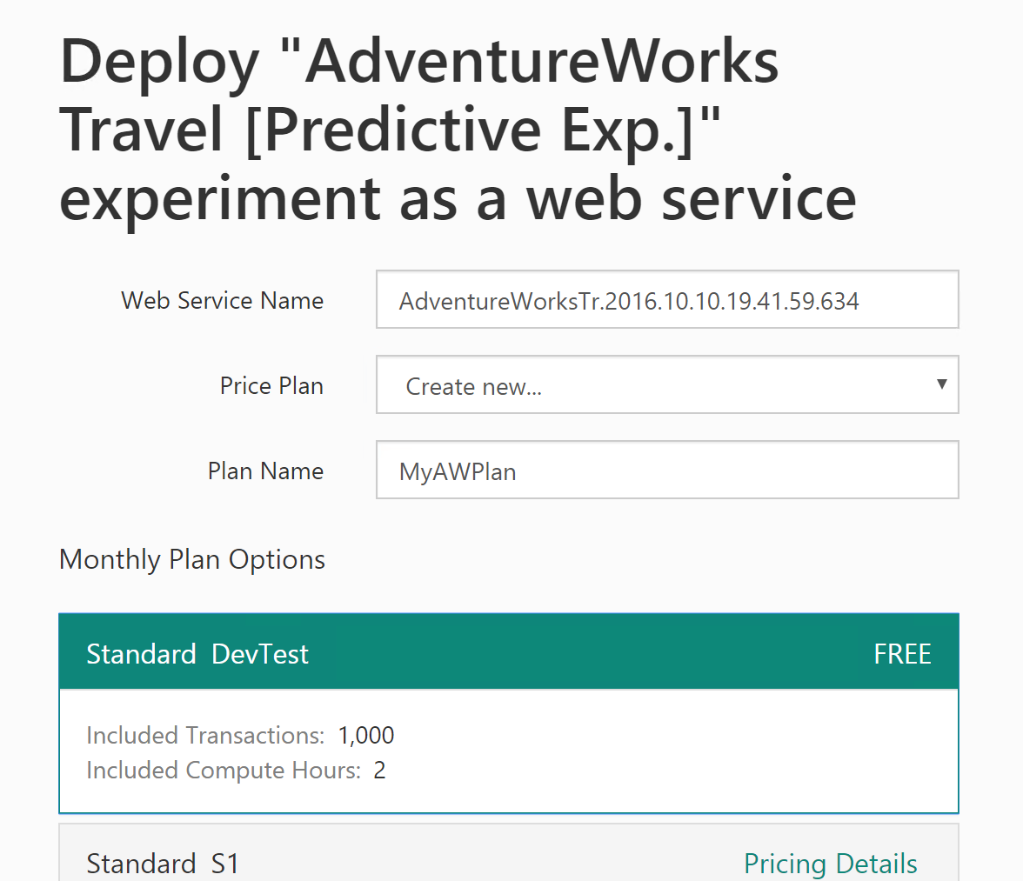

1. Scroll down and click the **Deploy** button.
2. After deployment is completed, you will be taken to the web services **Quick Start** page for your new web service.

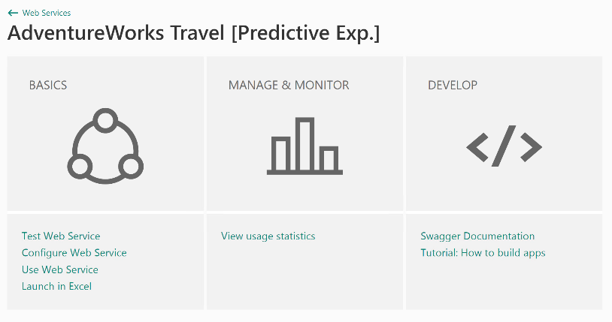

1. From the **Quick Start** page, click the **Use Web Service** link.
2. Click the Copy button for the **Primary key**, open a copy of Notepad, and paste the value in the editor.
3. Click the Copy button for the **Request-Response** link. The URL will look something like the following:

[https://ussouthcentral.services.azureml.net/subscriptions/***[SOME_GUID]***/services/***[SOME_OTHER_GUID]***/execute?api-version=2.0&format=swagger](https://ussouthcentral.services.azureml.net/subscriptions/%5BSOME_GUID%5D/services/%5BSOME_OTHER_GUID%5D/execute?api-version=2.0&format=swagger)

1. The first GUID after subscriptions is your Workspace ID. The second GUID after services is your Service ID.
2. Copy each of these values into Notepad as well. Make sure you note which GUID is which because you will need these in a later step.
3. Finally, copy the **Batch Requests** URL to Notepad as well, but make sure to remove the '?' character and everything after it. You should be left with a URL that looks something like the following. Again, make sure to label this as your batch service in your Notepad instance.

[https://ussouthcentral.services.azureml.net/subscriptions/***[SOME_GUID]***/services/***[SOME_OTHER_GUID]***/jobs](https://ussouthcentral.services.azureml.net/subscriptions/%5BSOME_GUID%5D/services/%5BSOME_OTHER_GUID%5D/jobs)

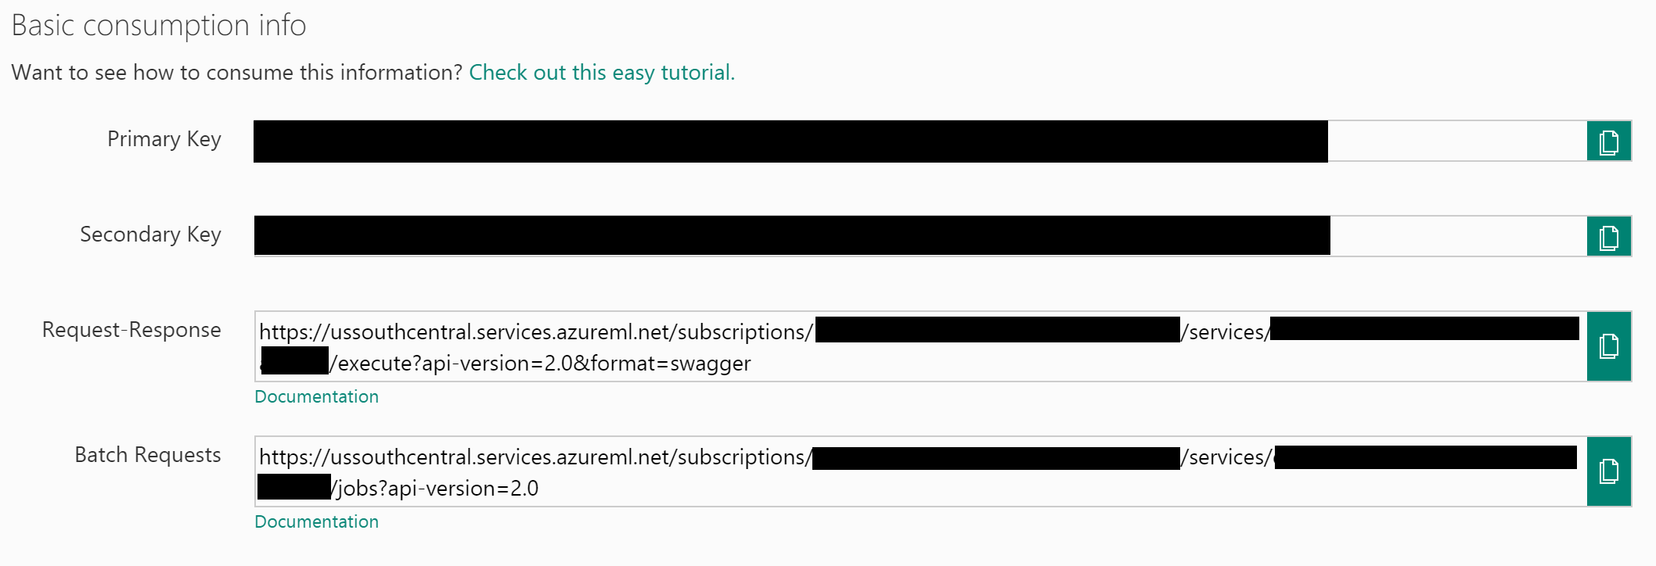

## Exercise 2: Setup Azure Data Factory

Duration: 20 mins

Synopsis: In this exercise, attendees will create a baseline environment for Azure Data Factory development for further operationalization of data movement and processing. They will create a Data Factory service and then install the Data Management Gateway which is the agent that facilitates data movement from on-premises to Microsoft Azure.

### **Task 1: Log in to the Lab VM**

1. From the left side of the Azure portal, click on **Browse >.**
2. In the **filter** box, type in **virtual.**
3. Click on **Virtual Machine**.



1. Keep in mind the name of the virtual machine will be the “APPNAME” you provided when setting up this workshop environment.
2. Click on the **<YOUR_APP_NAME>lab** virtual machine from the list and click on **Connect**.



1. Download and open the RDP file.
2. When Remote Desktop Connection screen appear, check the box **Don’t ask…** and click on **Connect** button.



1. Log in with the credentials you specified for the Lab VM during the deployment of the workshop prerequisites.

### **Task 2: Install and Configure Data Management Gateway on the Lab VM**

1. Using File Explorer go to “**C:\ADF_Gateway**” folder in the Virtual Machine.
2. **Install Data Management Gateway** by executing Data Management Gateway install package, “**DataManagementGateway_2.12.6414.2 (64-bit)**”.
3. When you see the following screen, click on the **Next** button.

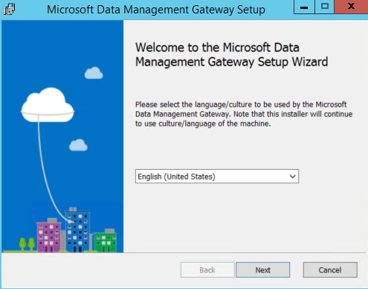

1. Check the **box** to accept the terms and click **Next** button.
2. Click **Next**.
3. Click **Install**.
4. Click **Finish**.
5. Once the installation is complete, the following screen will appear; **Stop** and **keep it open** for now. Next, you will provision the Data Factory service in Azure and obtain the gateway key so we can connect Data Factory to this “on-premises” server.

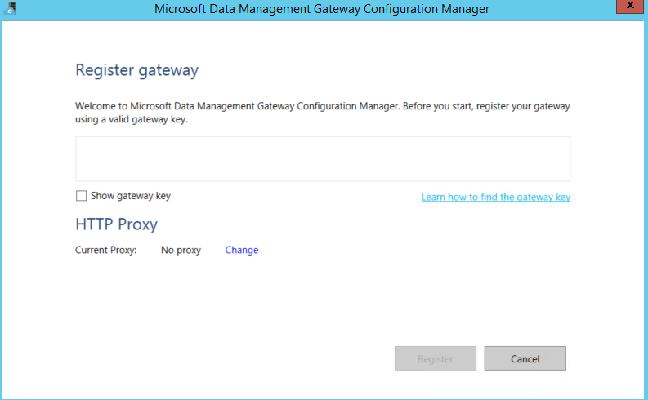

### **Task 4: Create new Azure Data Factory Service**

1. Launch a new browser (or tab) session and navigate to <https://portal.azure.com>.
2. From left top corner of the Azure Portal, click on **+New**.

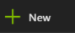

1. Select **Data + Analytics**, click on **Data Factory**.

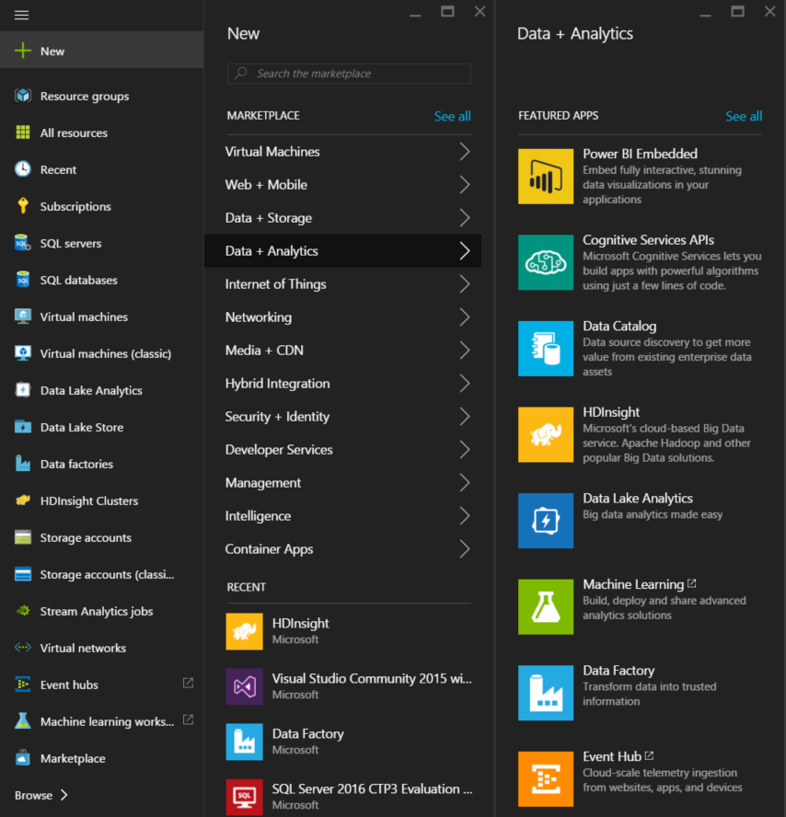

1. Provide a Name [*insert your initial here*]-adf (example “jcho-adf”).
2. Make sure to you have the right subscription selected.
3. For Resource Group, choose **Use Existing** and select the Resource Group you created when deploying the workshop prerequisites.
4. Select **East US** or **West US** for the region.
5. Check the box **Pin to dashboard** and click on the **Create** button.

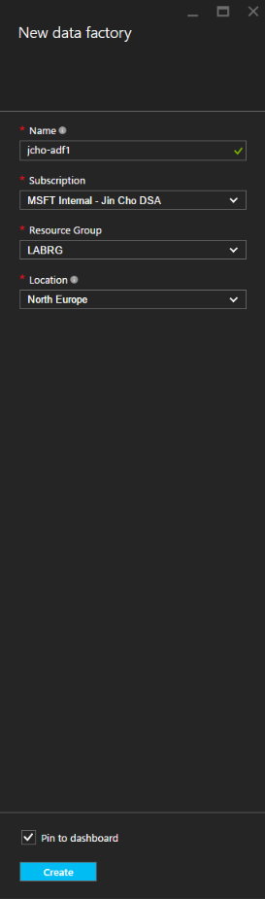

1. Deployment of the ADF will take couple of minutes.
2. Once it has completed, you will be taken to the Data Factory blade.
3. Click on **Author and deploy.**

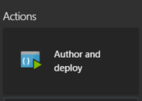

1. Click on “**…More**”



1. Click on **New data gateway.**



1. Type in **Data gateway name**. [insert your initial here]-dmg (example “**name-dmg”)**. And leave HA&Scalability(preview) default option which is **NO**.

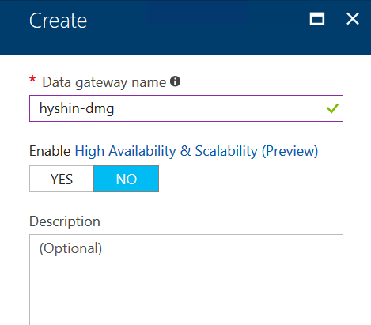

1. Click **OK** button.
2. Click on **Configure** and **copy** out the **NEW KEY**.
3. **Don’t close the current browser session**.
4. Go back to the Remote Desktop session of the virtual machine.
5. Paste the **Key** into the box in the middle of the screen.

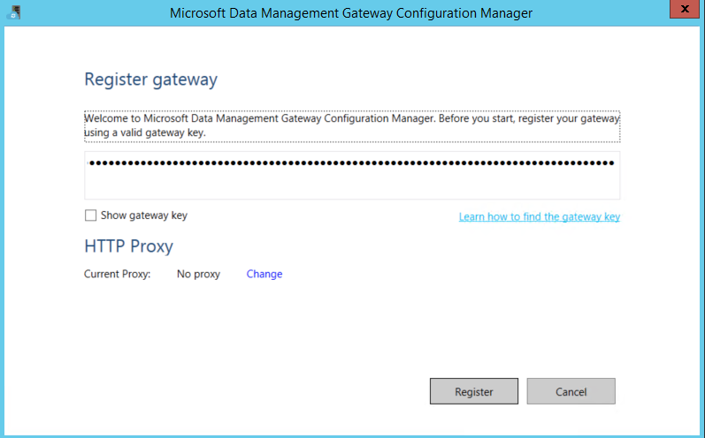

1. Click on the **Register** button.
2. It will take couple of minutes to register. If it takes more than couple minutes and the screen does not respond or get an error message, then close the screen by click on **Cancel** button.
3. You should see below screen with confirmation message.

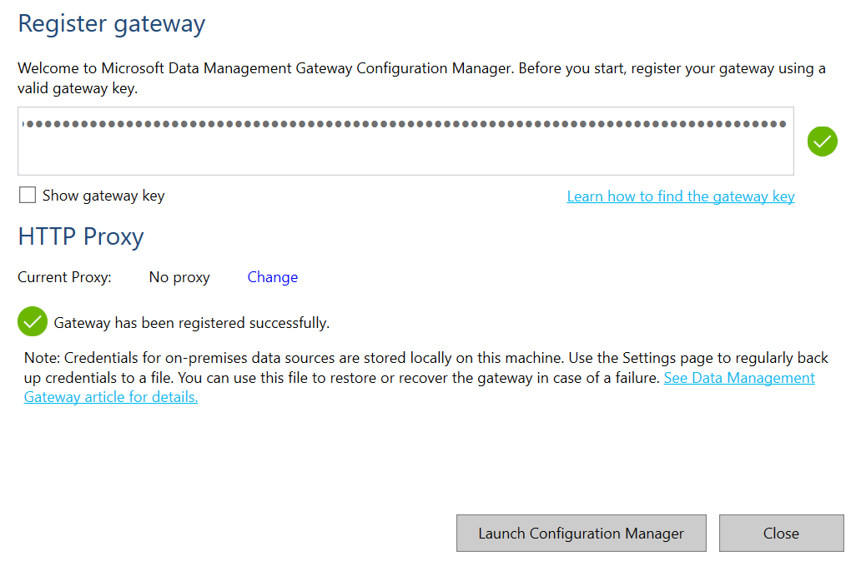

1. Confirmed that gateway is connected by going to the system tray of the bottom right corner and double click on the follow icon.

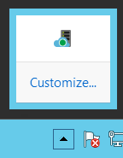

1. You should see following screen.

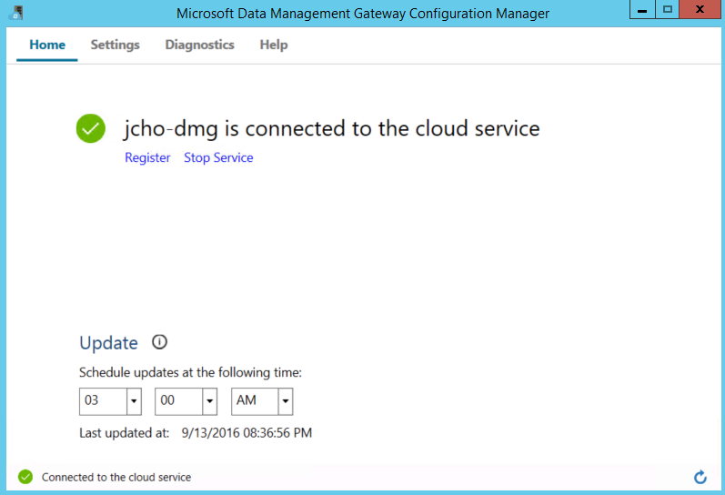

1. You can go back to the Azure Data Factory browser page within the **Azure Portal**, and Click **OK twice** to finish setting up the Data gateway.

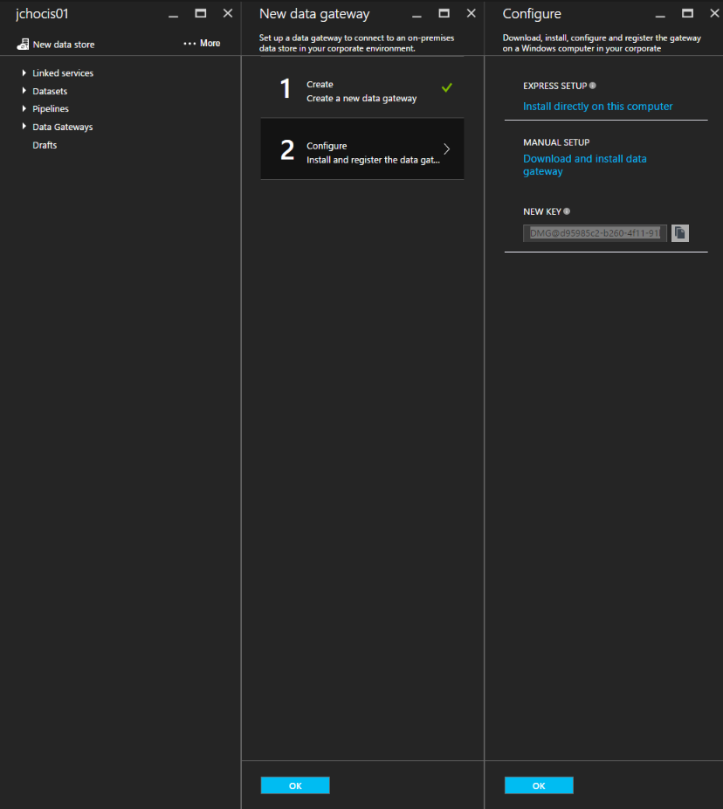

## **Exercise 3: Develop Data Factory Pipeline for Data Movement**

Duration: 20 mins

Synopsis: In this exercise, attendees will implement Azure Data Factory pipeline to copy data (.csv file) from on-premises server (lab virtual machine) to Azure Blob Storage. The goal of the exercise is to demonstrate data movement from an on-premises location to Azure Storage (via the Data Management Gateway). The attendee will see how these assets are created, deployed, executed, and monitored.

### **Task 1: Create copy pipeline using the Copy data wizard**

1. Go the Azure Portal and select Azure Data Factory (ADF) Service you create in previous exercise.

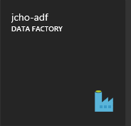

1. From **Actions** section, click on **Copy data.**

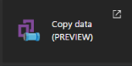

1. New browser window will open. Under Properties tab, type in “**CopyPipeline–OnPrem2Azure**”

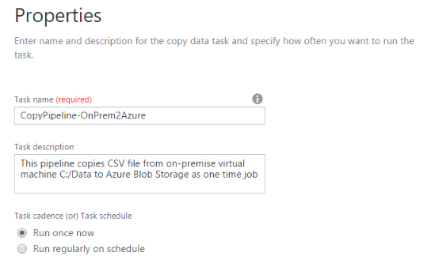

1. Select the “**Run once now**” option
2. Click on the **Next** button from the bottom of the screen.
3. From the Source Data Store screen tab, select **File System**.

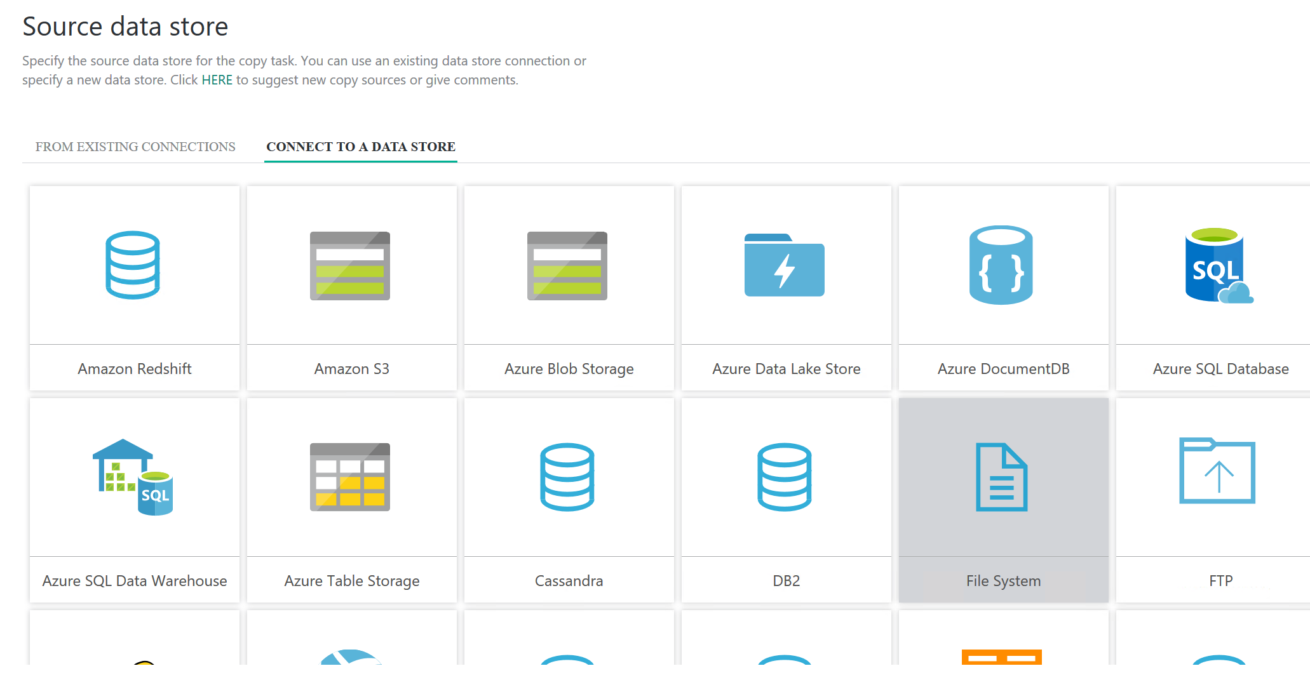

1. Click on **Next** button from the bottom of the screen.
2. From the Specify File Server share connection tab, type “**InputLinkedService-OnPremServer**” into the **Linked service name.**
3. For the Gateway, it should already have been filled in with the gateway connection you created in the previous exercise.
4. For the **Path**, type in “**C:\Data**”.
5. For the Credential encryption, select “**By web browser**”.
6. For the **User name**, type in the user name that was used to log into the lab virtual machine. “**cortana**”
7. For the **Password,** type in the password that was used to log into the lab virtual machine. “**Password.1!!**”

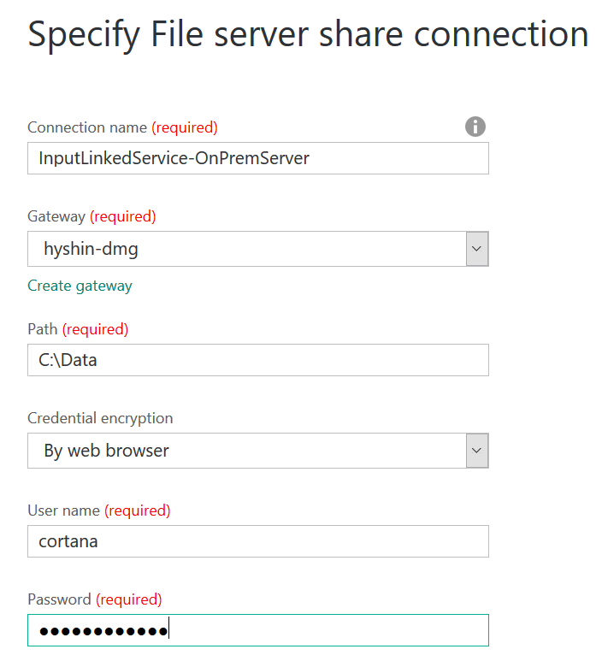

1. Click on the **Next** button from the bottom of the screen.
2. From the **Choose the input file or folder** tab, click on the “**FlightsAndWeather.csv**”.
3. Click on the **Choose** button from the bottom right corner of the screen.
4. Click on the **Next** button from the bottom of the screen.

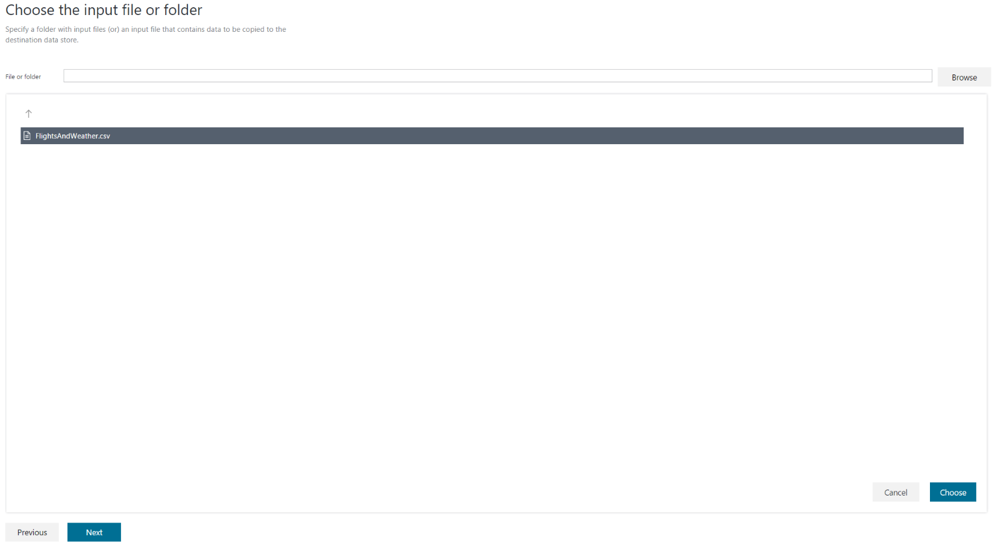

1. From the File format settings tab, leave everything as defaulted except check the box **Column name in the first data row**. You can see the preview of the file from the bottom of the screen.
2. Click **Next** button from the bottom of the screen.

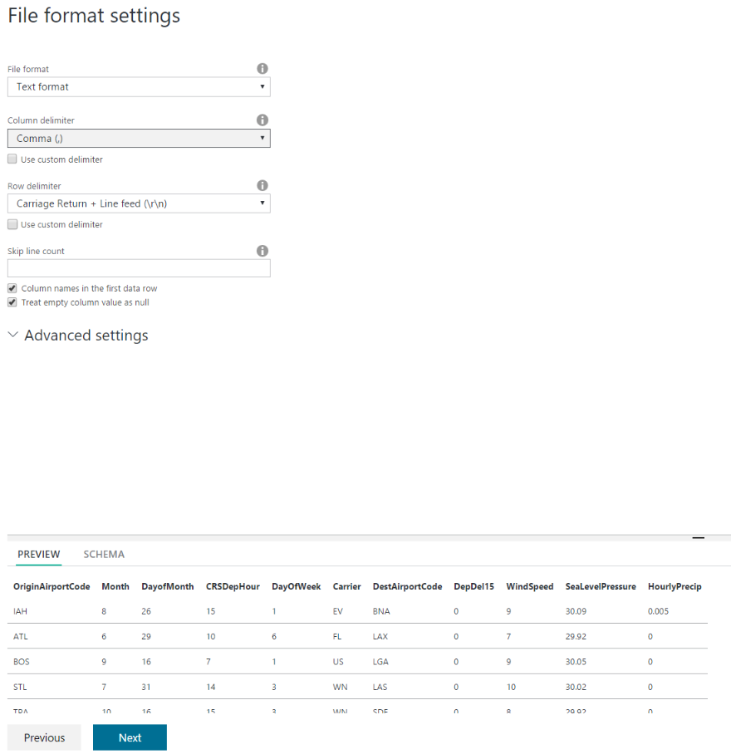

1. From the **Destination data store** tab, click on the **Azure Blob Storage**.
2. Click on the **Next** button from the bottom of the screen.

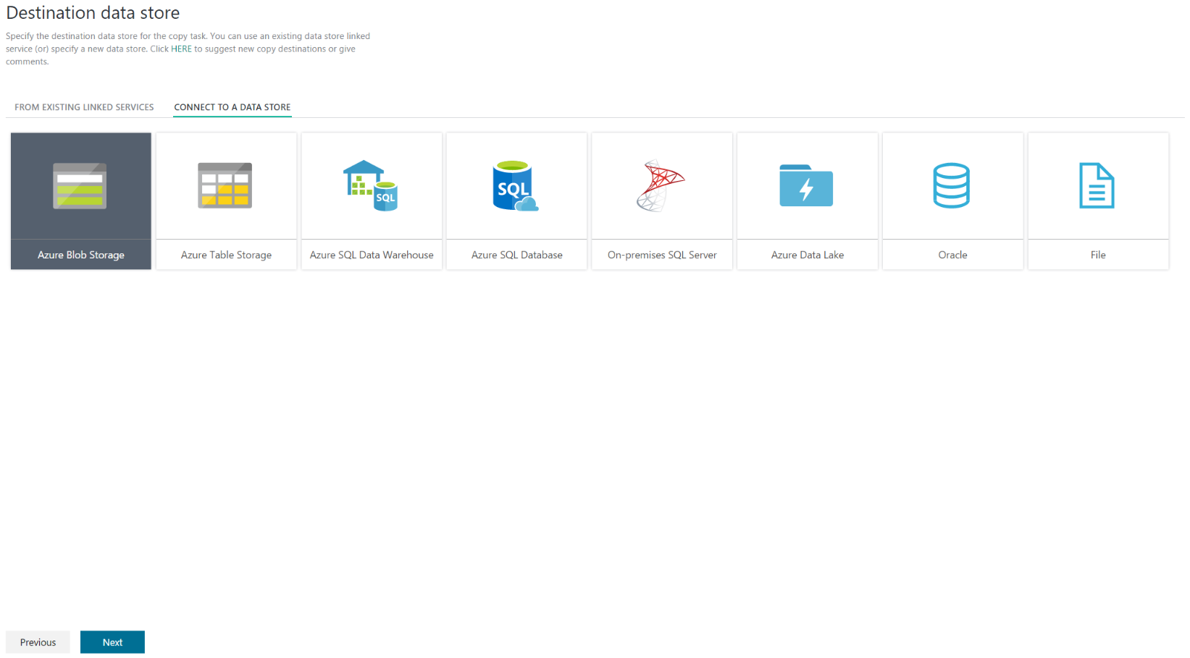

1. From the **Specify the Azure Blob storage account** tab, Type in “**OutputLinkedService-AzureBlobStorage**” into the **Linked service name**.
2. From the **Storage account name** dropdown list, select “**YOUR APPNAMEsparkstorage**”.
3. Click on the **Next** button from the bottom of the screen.

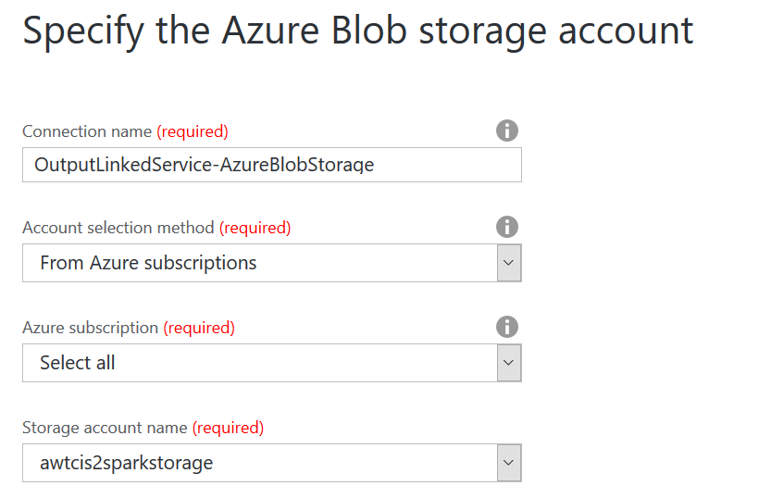

1. From the Choose the output file or folder tab, type in “**sparkcontainer/flights**” into the **folder path**.
2. Click on the **Next** button from the bottom of the screen.

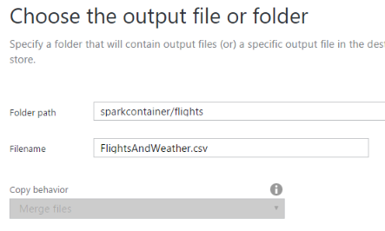

1. From the File format settings tab, leave everything as defaulted except check the box **Add header to file**. You can see the preview of the file from the bottom of the screen.
2. Click **Next** button from the bottom of the screen.

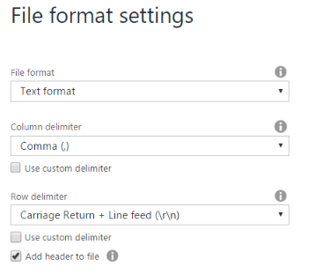

1. For the fault tolerance settings, leaves default and click **next**.

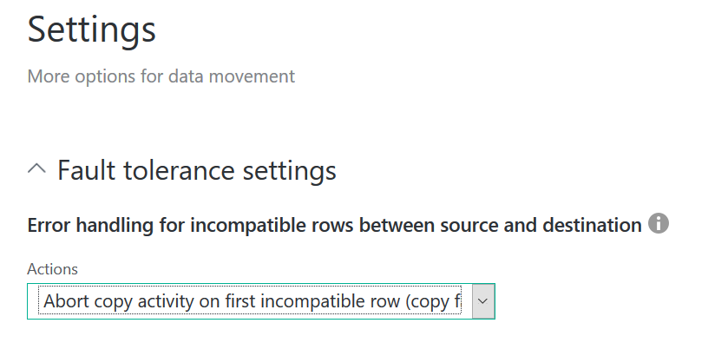

1. Review the **summary** tab and click **Finish** button from the bottom.
2. You should see **Deploying**… status. This process will take few minutes and see the **Deployment Complete** status on top of the screen.

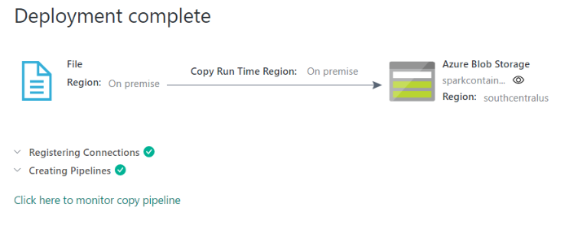

1. Click on the hyperlink “**Click here to monitor copy pipeline**”.
2. From the **Resource Explorer**, you should see yours from the **Activity Windows** (bottom of the screen) the pipleline activity status “**Ready**”. This indicates the CSV file was successfully copied from virtual machine to the Azure Blob Storage location.

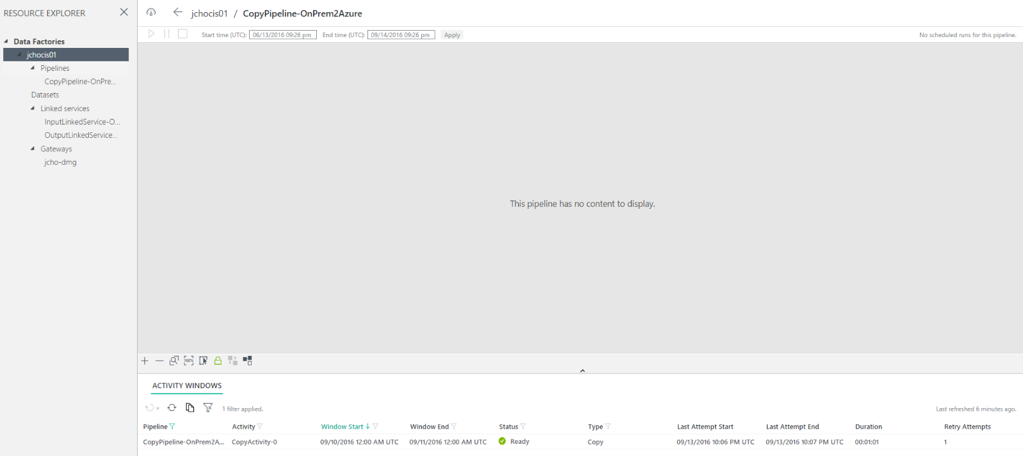

## **Exercise 4: Operationalize ML Scoring with Azure ML and Data Factory**

Duration: 20 mins

Synopsis: In this exercise, attendees will extend the Data Factory service to operationalize the scoring of data using the previously created ML model.

### **Task 1: Create Azure ML Linked Service**

1. Go back to the **Azure Data Factory** service blade.
2. Click on the **Author and deploy** from **Actions** section.

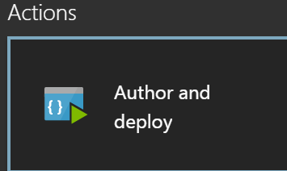

1. Click on **…More**.



1. Click on **New Compute**.



1. Select **Azure ML** from the list.
2. In the new window, be sure change the JSON file to match the following:
   1. Remove all three <(Optional)> rows.



* 1. In the new window, be sure change the JSON file to match the following or copy the below JSON text and paste into the browser window. You can also copy this from.
  2. Be sure to follow steps, you need to obtain **mlEndPoint** URL, **apiKey** and **tenant** value. Following code also can be found <http://bit.ly/2eQsUnH>.

|  |
| --- |
| {  "name": "AzureMLLinkedService",  "properties": {  "type": "AzureML",  "description": "",  "typeProperties": {  "mlEndpoint": "<Specify the batch scoring URL>",  "apiKey": "<Specify the published workspace model's API key>"  “tenant”: “<default tenant will be shown>”  }  }  } |

**If you already know mlEndpoint, apiKey and tenant, then skip following step d to i.**

* 1. **Open a New browser tab** and navigate to <https://services.azureml.net> your ML Studio and click **Web Services**.

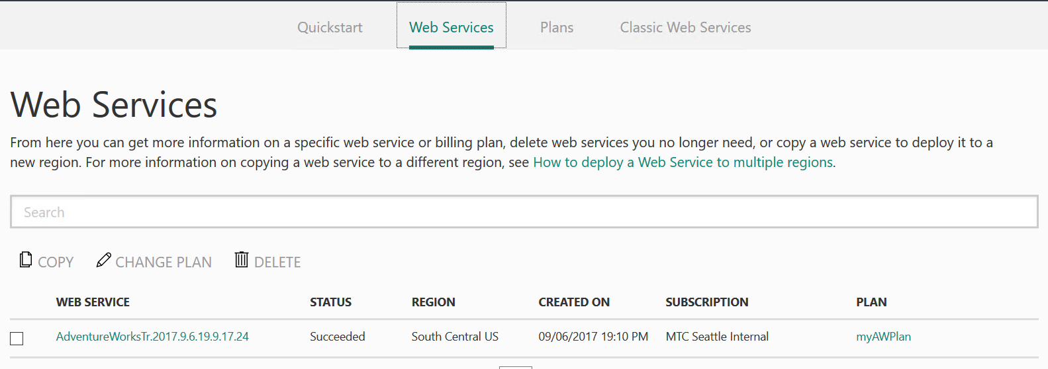

* 1. **Click** on your web service.
  2. **Click** “Use Web Service”

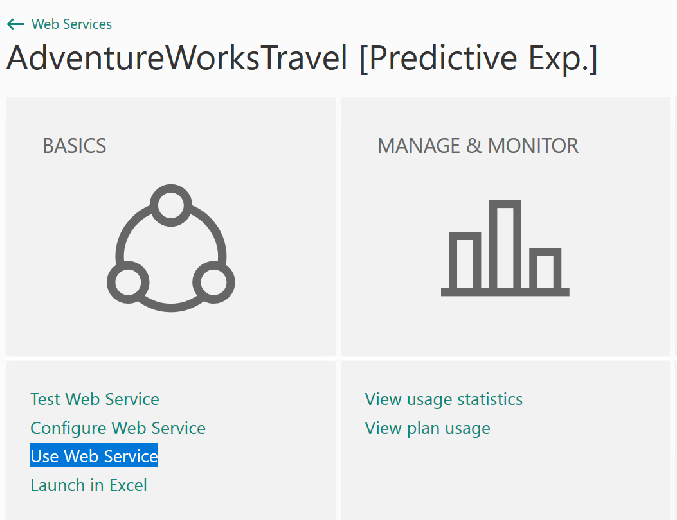

* 1. On this page, take note of the API key. Copy the **API key** value and paste it in for the **apiKey** above in the JSON.

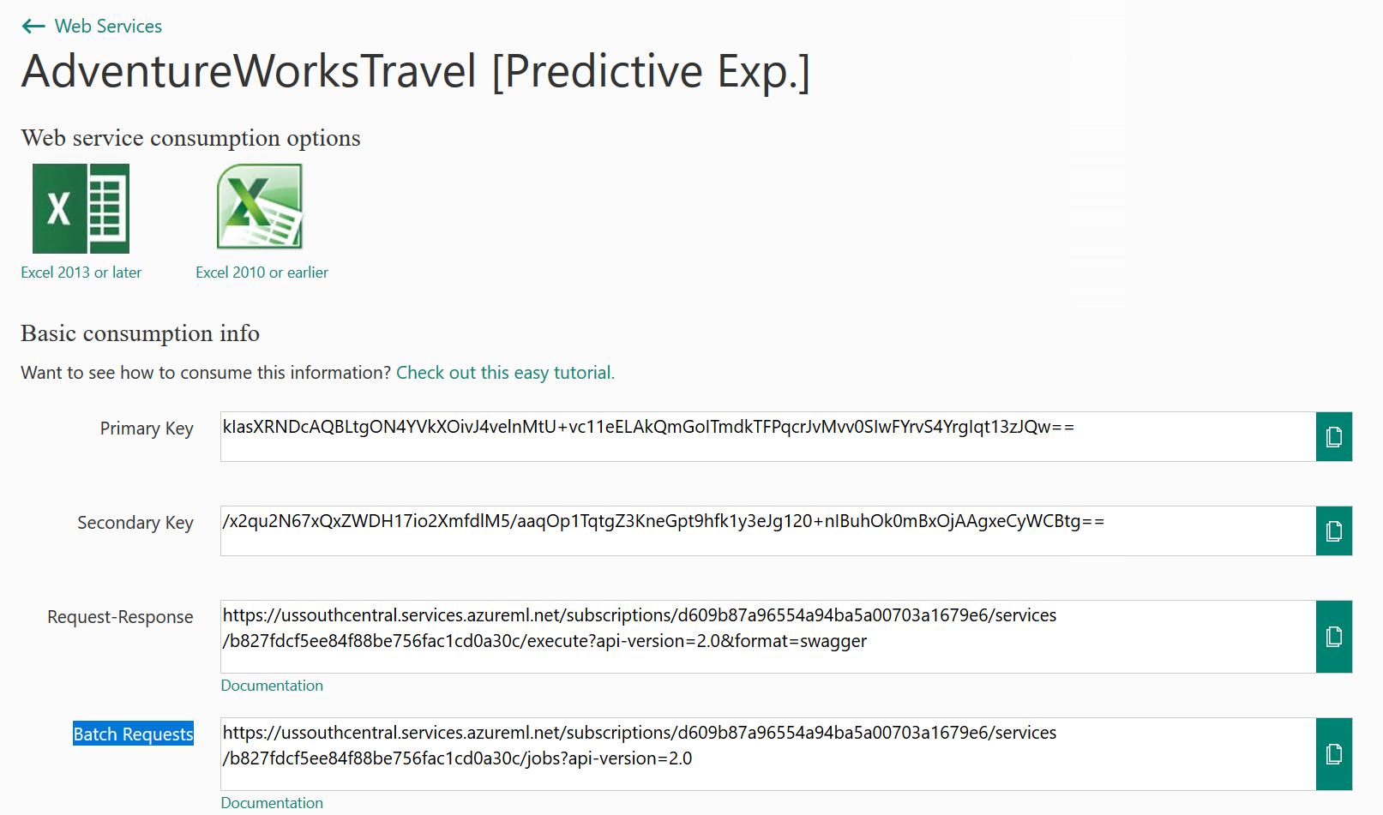

* 1. Below the Default Endpoint section, copy the URL starting at **https:** though (and including) **jobs** and paste it in for the **mlEndpoint**.
  2. Example URL: https://ussouthcentral.services.azureml.net/workspaces/64f94487f2bc476dae5e02b37b8d8b17/services/ad88ee0b5f54649963116bc98fa03ab/jobs

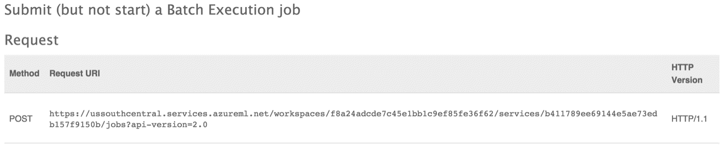

1. Go back to ADF editor the Azure Portal and click **Deploy.**

### **Task 2: Create Azure ML input dataset**

1. Continue work on Azure Data Factory Author and deploy windows. **Click** on …**More**.



1. To create new dataset that will be copied into Azure Blob storage, click on the **New dataset** from the top.



1. Select **Azure Blob storage** from the list.
2. In the new window, be sure change the JSON file to match the following or copy the below JSON text and paste into the browser window. You can also copy this from <http://bit.ly/2xS3j2v>.

|  |
| --- |
| {  "name": "AzureBlobDataInPut",  "properties": {  "type": "AzureBlob",  "external": true,  "linkedServiceName": "OutputLinkedService-AzureBlobStorage",  "typeProperties": {  "fileName": "FlightsAndWeather.csv",  "folderPath": "sparkcontainer/flights",  "format": {  "type": "TextFormat"  }  },  "availability": {  "frequency": "Minute",  "interval": 60  }  }  } |

1. Click **Deploy**.

### **Task 3: Create Azure ML scored dataset**

1. Click on **…More**.



1. Click on the **New dataset**.



1. Select **Azure** **Blob storage** from the list. In the new window, be sure change the JSON file to match the following or copy the below JSON text and paste into the browser window. You can also copy this from <http://bit.ly/2fdF0UR>.

|  |
| --- |
| {  "name": "AzureBlobScoredDataOutPut",  "properties": {  "type": "AzureBlob",  "linkedServiceName": "OutputLinkedService-AzureBlobStorage",  "typeProperties": {  "fileName": "Scored_FlightsAndWeather.csv",  "folderPath": "sparkcontainer/flights",  "format": {  "type": "TextFormat"  }  },  "availability": {  "frequency": "Minute",  "interval": 60  }  }  } |

1. Click **Deploy**.

### **Task 4: Create Azure ML predictive pipeline**

1. Click on **…More**.



1. Click on the **New pipeline**.



1. In the new window, be sure change the JSON file to match the following or copy the below JSON text and paste into the browser window. You can also copy this from <http://bit.ly/2ePqUwe>.

|  |
| --- |
| {  "name": "PredictivePipeline",  "properties": {  "description": "Use AzureML model",  "activities": [  {  "type": "AzureMLBatchExecution",  "typeProperties": {  "webServiceInput": "AzureBlobDataInPut",  "webServiceOutputs": {  "output1": "AzureBlobScoredDataOutPut"  },  "globalParameters": {}  },  "inputs": [  {  "name": "AzureBlobDataInPut"  }  ],  "outputs": [  {  "name": "AzureBlobScoredDataOutPut"  }  ],  "policy": {  "timeout": "02:00:00",  "concurrency": 1,  "executionPriorityOrder": "NewestFirst",  "retry": 1  },  "scheduler": {  "frequency": "Minute",  "interval": 60  },  "name": "MLActivity",  "description": "prediction analysis on batch input",  "linkedServiceName": "AzureMLLinkedService"  }  ],  "start": "**YYYY-MM-DDT00:00:00Z**",  "end": "**YYYY-MM-D1T00:00:00Z**"  }  } |

1. Make sure to change the **start** **YYYY-MM-DDT00:00:00Z** to today’s date and **end** to today+1 (tomorrow) date.
2. Click **Deploy**. It may take few minutes.

### **Task 5: Monitor your pipeline activities**

1. Close the current blade by clicking on the **X** from the top right corner of the blade.
2. Click on the **Monitor & Manage** from the **Actions** section.

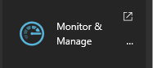

1. Maximize the new window and you can see the diagram view of the data flow.

**Insert new image here.**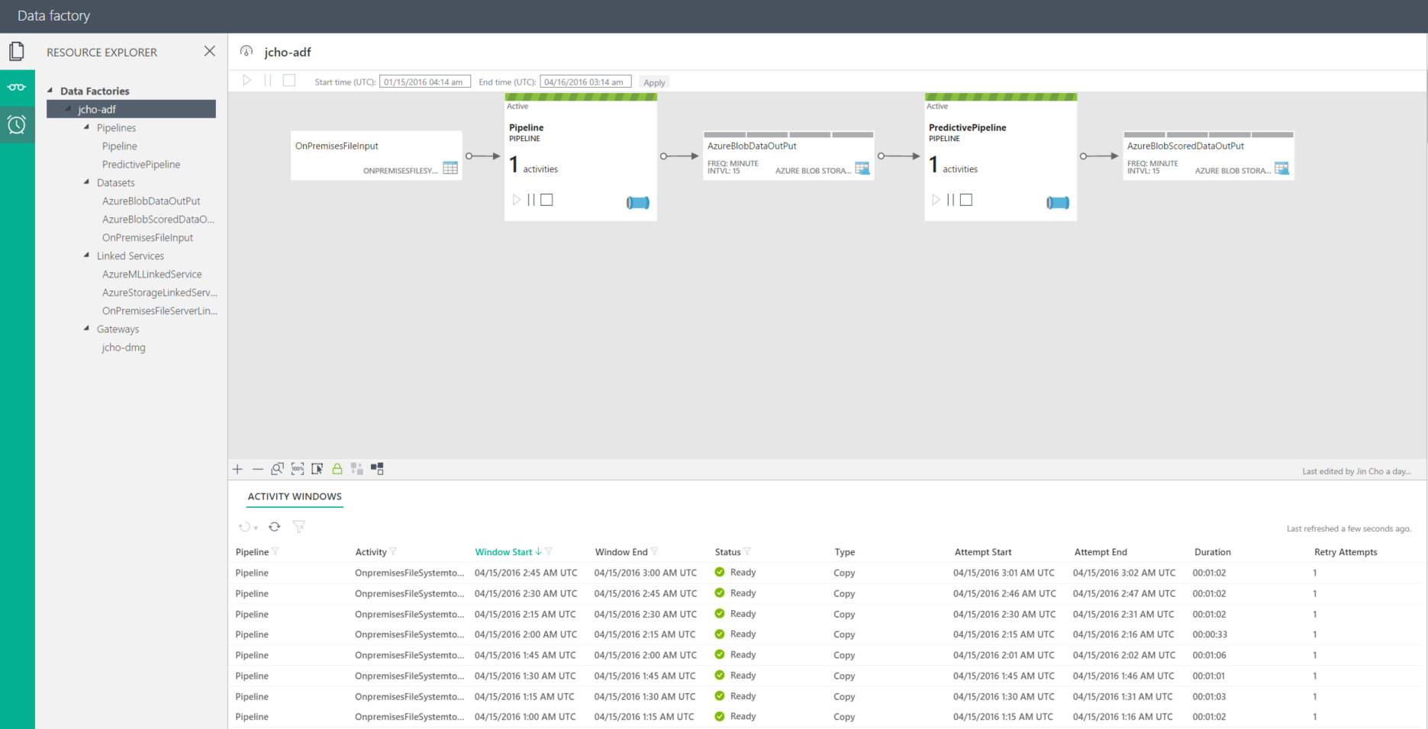

1. You should start to see **Ready** status activity listed on the bottom of the new window.
2. Close the **Monitor & Manage** browser tab.

## **Exercise 5: Summarize Data Using HDInsight Spark**

Duration: 60 mins

Synopsis: In this exercise, attendees will prepare a summary of flight delay data in HDFS using Spark SQL.

### **Task 1: Summarize delays by airport**

1. Navigate to the blade for your Spark Cluster in the Azure Portal.

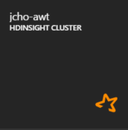

1. In the Quick Links section, click **Cluster** **Dashboards**.

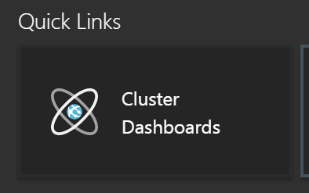

1. From the **Cluster Dashboards**, click **Jupyter Notebooks**. You will have to login with the cluster username/password at this step.

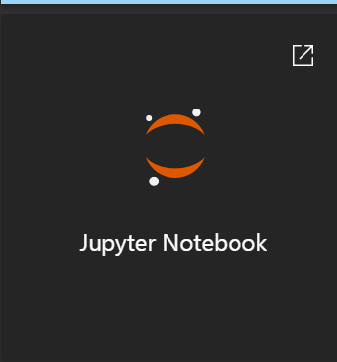

1. On the **Jupyter notebooks** screen, click on the **New** dropdown list from top right corner and click **Spark**.

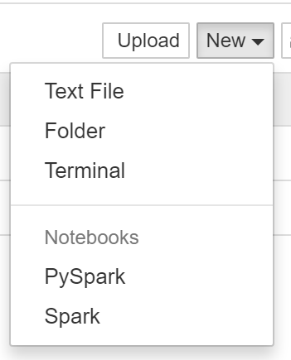

1. Copy the below text and paste it into the Jupyter notebook. Alternatively, copy from[**http://bit.ly/2eKBQYc**](http://bit.ly/2eKBQYc).

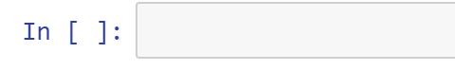

|  |
| --- |
| import sqlContext.implicits._  val flightDelayTextLines = sc.textFile("wasb:///flights//Scored_FlightsAndWeather.csv")  case class AirportFlightDelays(OriginAirportCode:String,OriginLatLong:String,Month:Integer,Day:Integer,Hour:Integer,Carrier:String,DelayPredicted:Integer,DelayProbability:Double)  val flightDelayRowsWithoutHeader = flightDelayTextLines.map(s => s.split(",")).filter(line => line(0) != "OriginAirportCode")  val resultDataFrame = flightDelayRowsWithoutHeader.map(  s => AirportFlightDelays(  s(0), //Airport code  s(13) + "," + s(14), //Lat,Long  s(1).toInt, //Month  s(2).toInt, //Day  s(3).toInt, //Hour  s(5), //Carrier  s(11).toInt, //DelayPredicted  s(12).toDouble //DelayProbability  )  ).toDF()  resultDataFrame.write.mode("overwrite").saveAsTable("FlightDelays") |

1. Click the **Play** icon in the top of the screen to execute this code and create the FlightDelays table.



1. Click in the empty paragraph below the paragraph in which you entered your Scala script. In this paragraph, you are going to author a SQL query to view the results of the table you just created. To switch from running Scala code, to running SQL, your first line in the paragraph must start with %. This code can be copied from[**http://bit.ly/2gLGoOA**](http://bit.ly/2gLGoOA)

|  |
| --- |
| %%sql  SELECT * FROM FlightDelays |

1. Click on the **Table** button to choose Type.
2. You should see the results appear in a table form similar to the following:

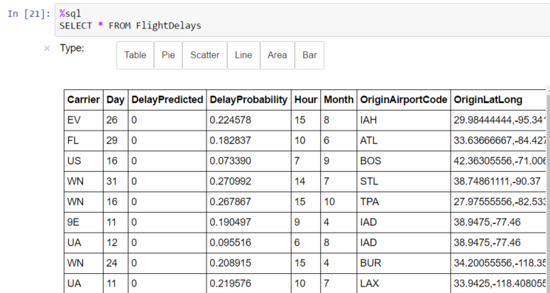

1. Next, you will create a table that summarizes the flight delays data. Instead of containing one row per flight, this new summary table will contain one row per origin airport at a given hour along with a count of the quantity of anticipated delays.
2. In a new paragraph below, try running the following query. [**http://bit.ly/2eQ4A5j**](http://bit.ly/2eQ4A5j)

|  |
| --- |
| %%sql  SELECT OriginAirportCode, OriginLatLong, Month, Day, Hour, Sum(DelayPredicted) NumDelays, Avg(DelayProbability) AvgDelayProbability  FROM FlightDelays  WHERE Month = 4  GROUP BY OriginAirportCode, OriginLatLong, Month, Day, Hour  Having Sum(DelayPredicted) > 1 |

1. Click the **Play** icon in the top of the screen to execute this code.



1. This query should return a table that appears similar to the following:

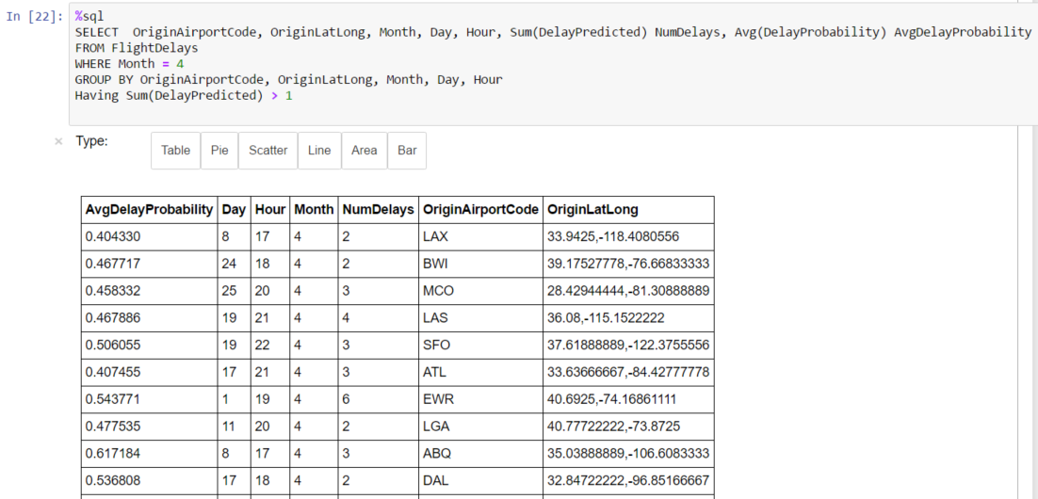

1. Since the summary data looks good, the final step is save this summary calculation as a table that we can later query using Power BI.
2. To accomplish creating the table, enter a new paragraph and add the following Scala code and run it. [**http://bit.ly/2xfqOFC**](http://bit.ly/2xfqOFC)

|  |
| --- |
| val summary = sqlContext.sql("SELECT OriginAirportCode, OriginLatLong, Month, Day, Hour, Sum(DelayPredicted) NumDelays, Avg(DelayProbability) AvgDelayProbability FROM FlightDelays WHERE Month = 4 GROUP BY OriginAirportCode, OriginLatLong, Month, Day, Hour Having Sum(DelayPredicted) > 1")  summary.write.mode("overwrite").saveAsTable("FlightDelaysSummary") |

1. Click the **Play** icon in the top of the screen to execute this code.



1. To verify your table was successfully created, go to another new paragraph and enter and run the following query. [**http://bit.ly/2gMeBxE**](http://bit.ly/2gMeBxE)

|  |
| --- |
| %%sql  SELECT * FROM FlightDelaysSummary |

1. Click the **Play** icon in the top of the screen to execute this code.



1. You should see results similar to the following:

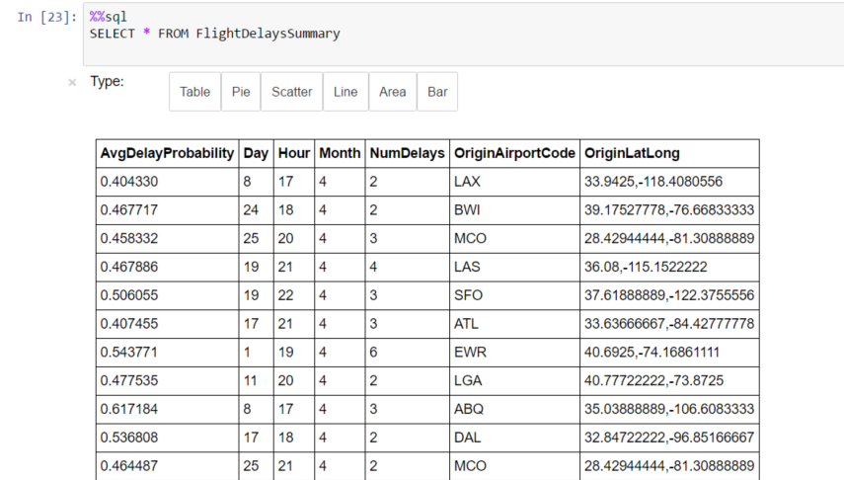

1. You can also click on the other buttons like **Pie, Scatter, Line, Area, and Bar** to view these visualizations.

## **Exercise 6: Visualizing in Power BI Desktop**

Duration: 20 mins

Synopsis: In this exercise, attendees will construct a report in Power BI Desktop Client that uses the map visualization to illustrate the predicted delays, using the data originally scored using Machine Learning, but summarized in a table using Spark on HDInsight.

### **Task 1: Connect to the Lab VM**

1. PowerBI desktop is already installed.

### **Task 2: Run Power BI Desktop and Connect to the HDInsight Spark using Power BI Desktop**

1. Launch Power BI Desktop using the shortcut on the Desktop of the Lab VM.
2. Click on **Get Data** from the left side of the welcome window.

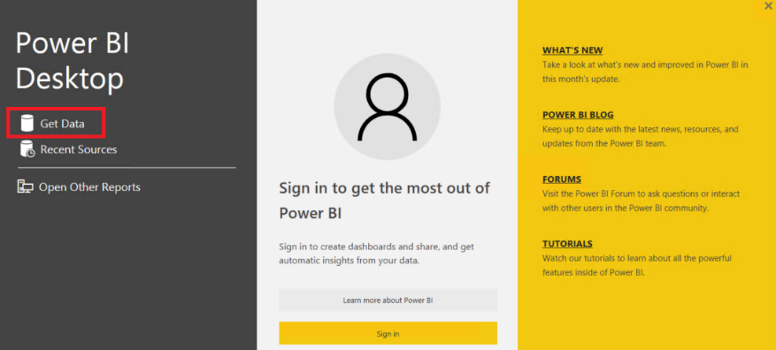

1. Click on the **Azure** from the left and select **Azure HDInsight Spark (Beta)** from the new **Get Data** window. Click on **Connect** button from the bottom right corner.

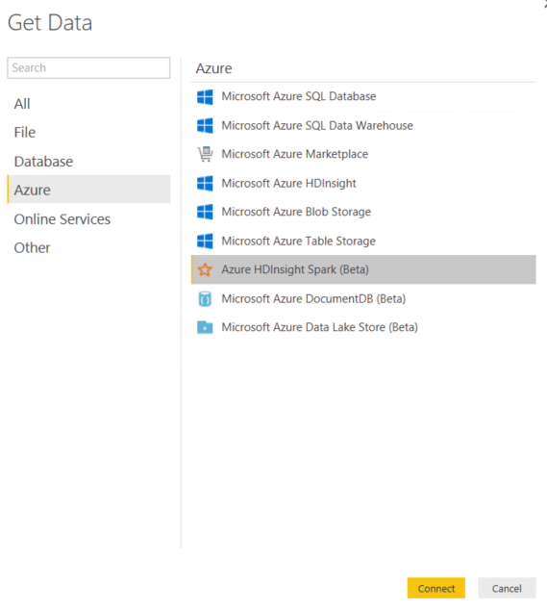

1. Click **Continue** from the bottom right corner of the new window.
2. Type or copy/paste the **URL** of your **Azure HDInsight Spark cluster**, which can be found from the address bar when connected to the Azure HDInsight Spark cluster in previous exercise 5. It should be look like this example: ***https://jcholab199spark.azurehdinsight.net***
3. Click **OK** button.
4. Enter the cluster user name and password

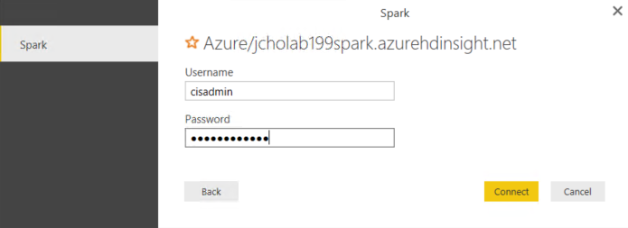

1. Give the system a few moments to connect to Spark and load the metadata.
2. When the dialog box disappears, look for the **flightdelaysummary** from the list.

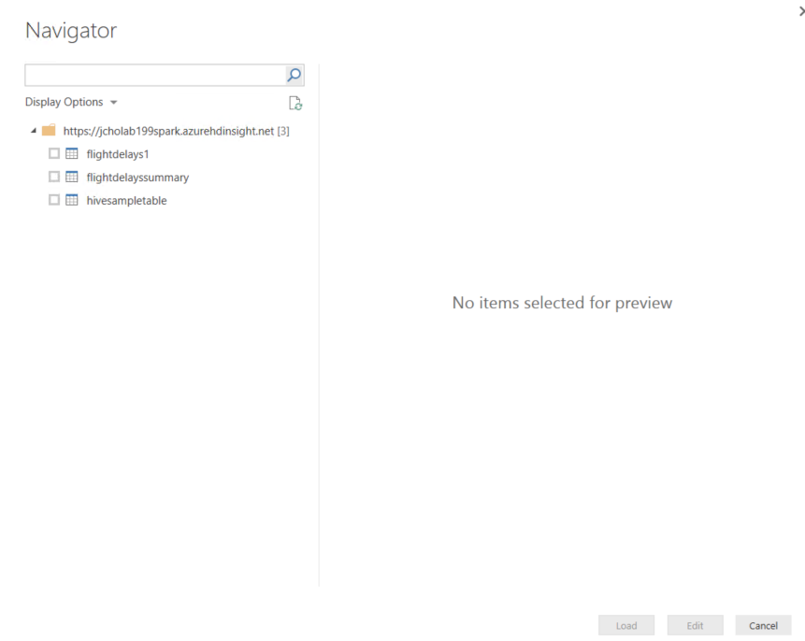

1. Select **flightdelaysummary** by checking box next to it.
2. Click on the **Load** button from the bottom right corner of the window.
3. It will take couple of minutes to load the data into the Power BI Desktop client.

### **Task 3: Create Power BI Report**

1. Once the data load is completed, you will find the **flightdelaysummary** to the right side of the screen under the **Fields** area.

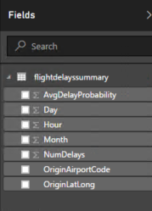

1. From the **Visualizations** area, which is left to the **Fields** area, click the **Globe** icon to add a Map visualization to the report design surface.



1. With the Map visualization still selected, in the **Fields** area at right, expand the tabled called **flightdelayssummary**.

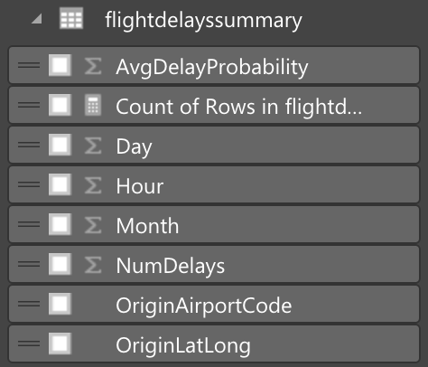

1. Click and drag the field labeled **OriginLatLong** and drop it into the **Location** field located just below visualizations.

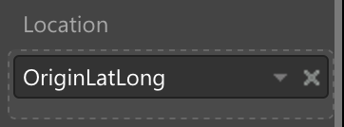

1. Next, drag the field labeled **NumDelays** and drop it into the **Size** field.

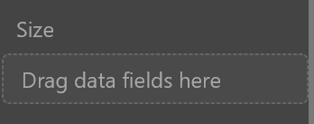

1. Your map should look something like the following:

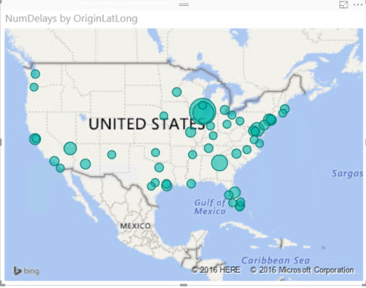

1. Unselect the Map visual by clicking on the white space on the report page.
2. From the **Visualizations** area, which is left to the **Fields** area, click the **Stacked Column Chart** icon to add a bar chart visualization to the report design surface.



1. With the **Stacked Column Chart** visualization still selected, in the Fields area at right, expand the tabled called **flightdelayssummary**.



1. Click and drag the field labeled **Day** and drop it into the **Axis** field located just below visualizations.

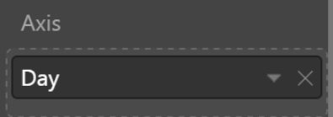

1. Next, drag the field labeled **AvgDelayProbability** and drop it into the **Value** field.

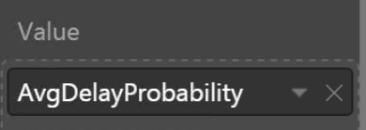

1. Grab the corner of the new **Stacked Column Chart** Visual and drag it out by making wide as the bottom of your report design surface.
2. Your report should look something like the following:

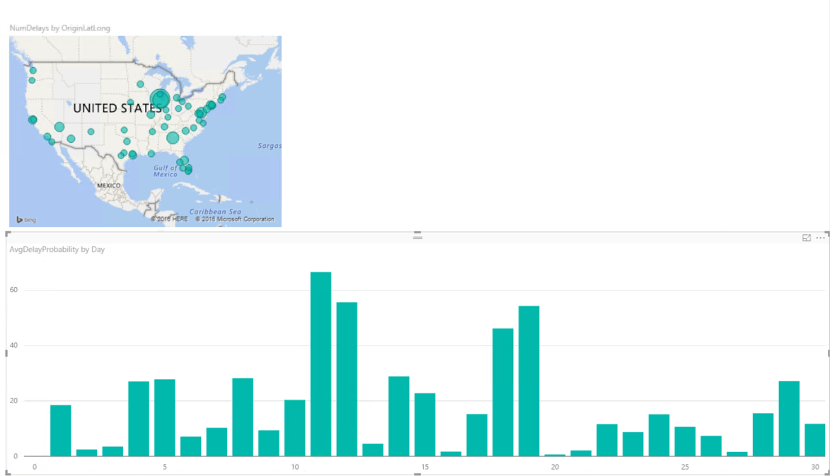

1. Unselect the Stacked Column Chart visual by clicking on the white space on the report page.
2. From the **Visualizations** area, which is left to the **Fields** area, click the **Treemap** icon to add this visualization to the report design surface.



1. With the **Treemap** visualization still selected, in the Fields area at right, expand the tabled called **flightdelayssummary**.



1. Click and drag the field labeled **OriginAirportCode** and drop it into the **Group** field located just below visualizations.

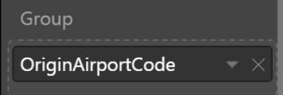

1. Next, drag the field labeled **NumDelays** and drop it into the **Value** field.

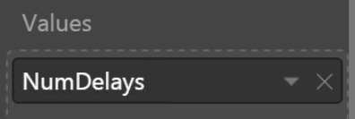

1. Grab the corner of the new **Treemap** Visual and drag it out by making wide as the top of your report design surface. Your report should look similar to the following:

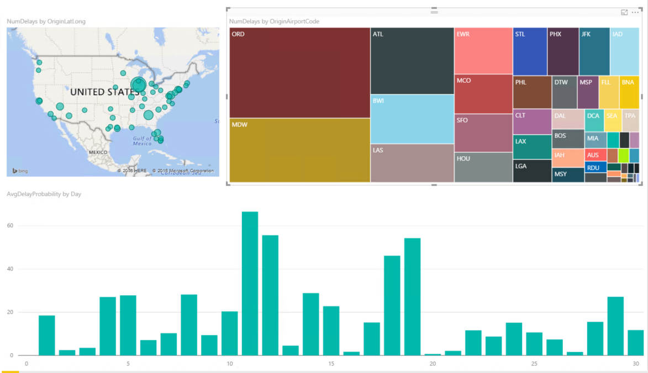

1. You can cross filter the visualizations on the report by click on the one of the other visuals within the report as shown below.

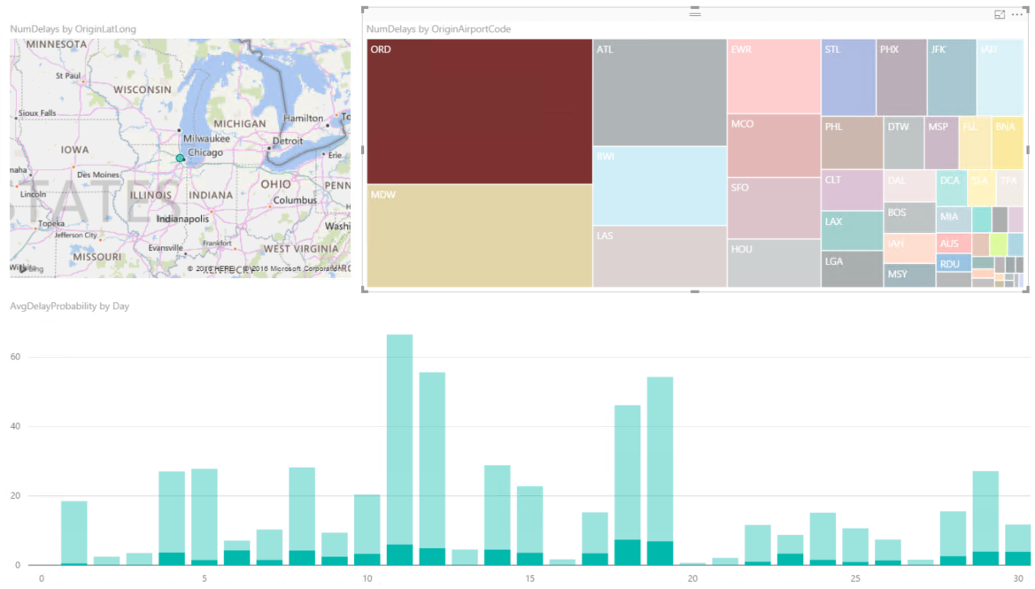

1. You can save this Power BI report by click on Save icon from the top left corner of the screen.

## **Exercise 7.1: Acquire Weather API Key**

Duration: 20 mins

Go to <http://bit.ly/2qsCLTM> and follow the instruction to get the Weather API Key.

## **Exercise 7.2: Deploy Intelligent Web App**

Duration: 20 mins

Synopsis: In this exercise, you will deploy an intelligent web application to Azure from GitHub. This application leverages the operationalized machine learning model that was deployed in Exercise 1 to bring action-oriented insight to an already existing business process. Before you start this exercise please make sure you are working on the VM.

### **Task 1: Deploy Web App from VM**

1. Open command prompt by executing “**cmd**”.

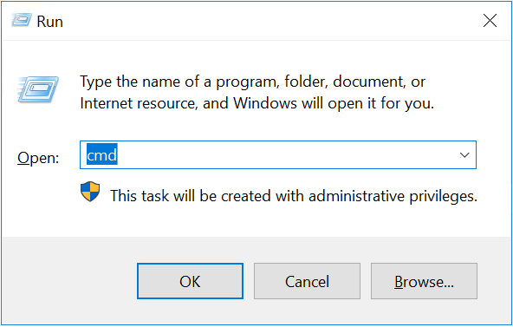

1. Navigate to “**C:\mywebapp**”.

|  |
| --- |
| cd \myWebApp |

### **Task 2: Commit your content**

1. From the command-line, verify that you are under the C:\myWebApp. Then use the following command to initialize and add files to your repository.

|  |
| --- |
| git init  git add -A |

1. Next, commit the changes to the repository by using the following command.

|  |
| --- |
| git commit -m “AWTApp” |

### **Step 3: Enable the App Service app repository**

1. Log in to the **Azure Portal.**
2. In your App Service app's blade, click **Settings > Deployment source**. Click Choose source, then **click Local Git Repository**, and then click **OK**.

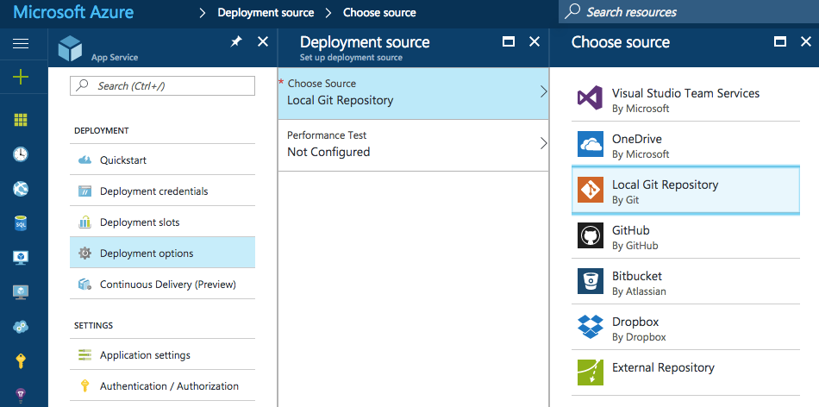

1. If this is your first time setting up a repository in Azure, you need to create login credentials for it. You will use them to log into the Azure repository and push changes from your local Git repository. From your app's blade, click **Settings > Deployment credentials**, then configure your deployment username and password. When you're done, click Save.

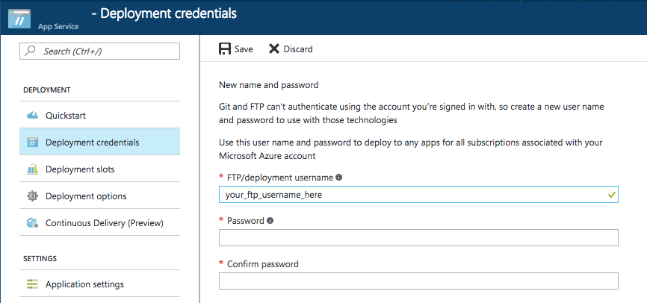

### **Task 4: Deploy your project**

1. In your app's blade in the Azure Portal, click **Settings > Properties** for the Git URL. Git URL is the remote reference to deploy to from your local repository. You'll use this URL in the following steps.

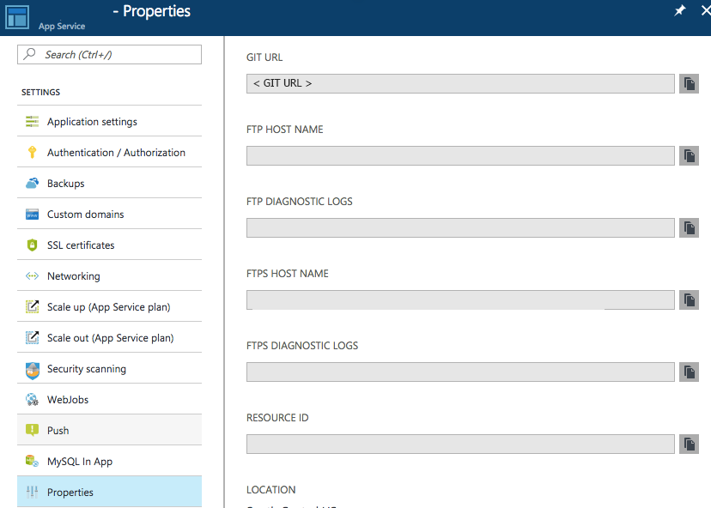

1. Using the command-line, verify that you are in the root of your local Git repository.

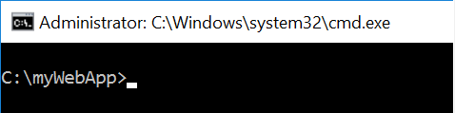

1. Use git remote to add the remote reference listed in Git URL from step 1. Your command will look like the following.

|  |
| --- |
| git remote add azure https://<username>@localgitdeployment.scm.azurewebsites.net:443/localgitdeployment.git |

1. By running following command, push your contents to App Service using the new azure remote you just created.

|  |
| --- |
| git push azure master |

1. Git will ask your credential to your web app. Use the deployment credentials you created previous task #3.

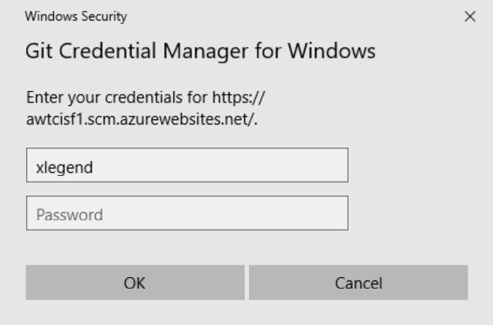

1. Go back to your app in the Azure Portal. A log entry of your most recent push should be displayed in the Deployments blade.

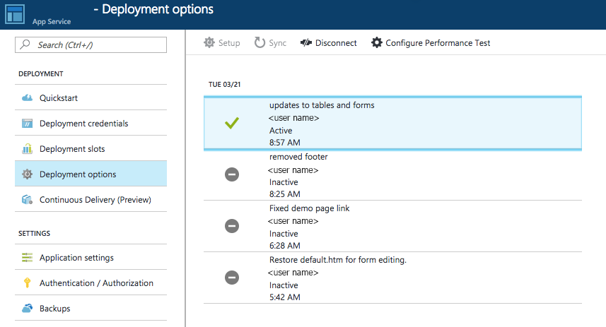

1. Lastly change app settings. Go to **Settings > Application Settings**, then find ‘App Settings’. Update value of each keys. And click save to store the updated values.

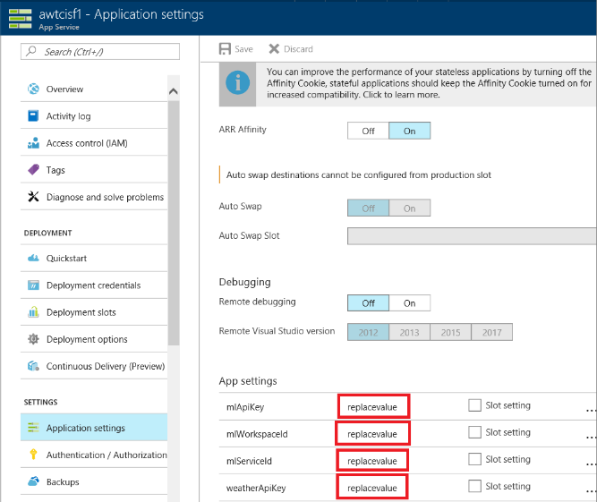

|  |  |
| --- | --- |
| KeyName | Value (*you can find the value from*) |
| mlApiKey | Exercise#1 Task 8. |
| mlWorkspaceId | Exercise#1 Task 8. |
| mlServiceId | Exercise#1 Task 8. |
| weatherApiKey | Exercise#7.1 |

1. Your web app deployment is done. Now go to your web. You can find your web app URL ‘Overview’.

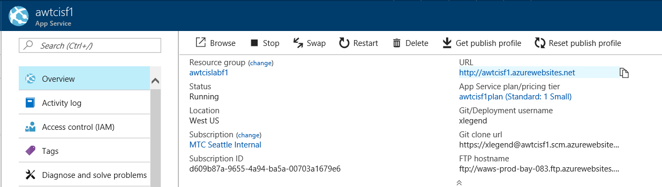

1. You will see Adventure Works Travel. By clicking ‘Predict Delay’, you can see the chance of flight delay.

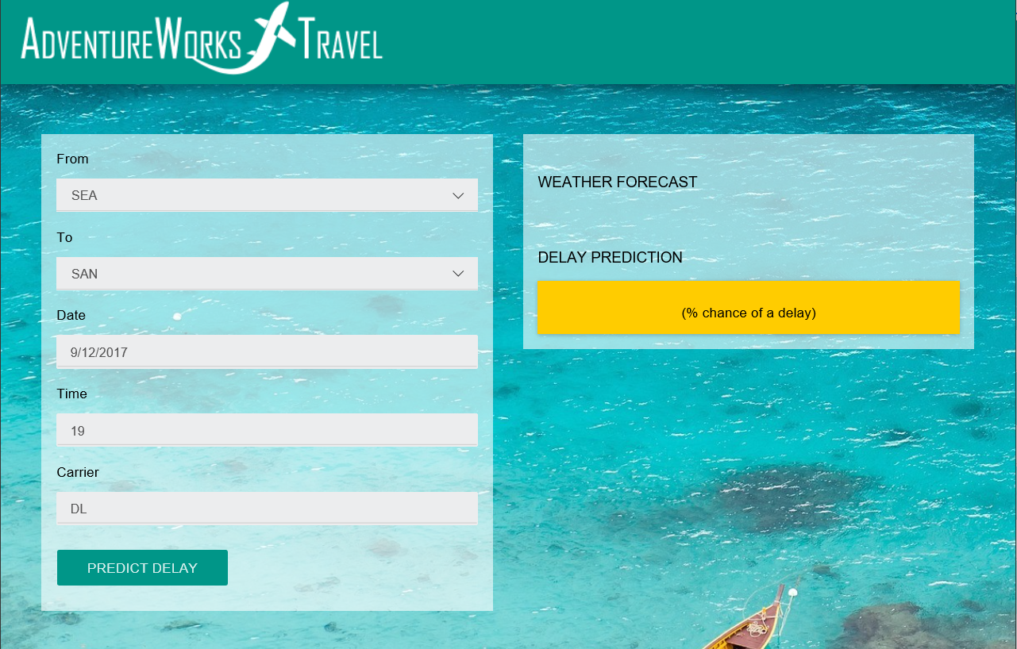

## Exercise 8: Cleanup of Azure resources

Duration: 10 mins

Synopsis: In this exercise, attendees will de-provision any Azure resources that were created in support of the lab.

### **Task 1: Delete Resource Group**

1. Using the Azure Portal, navigate to the Resource Group that you used throughout the lab by clicking on **Resource Groups** in the left nav.

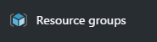

1. You will see the various assets created throughout the workshop, delete each one by clicking on it and then clicking the **Delete** button for each.
   1. For the App Service plan, you will first need to delete the Web App within the plan before deleting the plan itself.

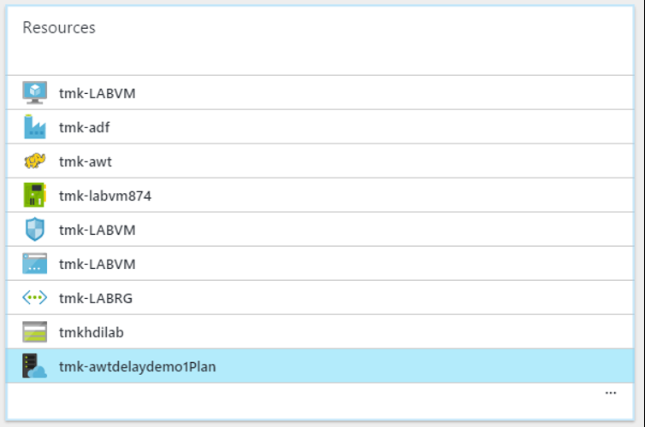



## Appendix A: Alternative to Azure ML Exercise

Duration: 20 mins

Synopsis: The purpose of this exercise is the same as Exercise 2 above. However, it is included as an alternative in the case attendees fall behind or are otherwise unable to complete the exercise. The attendee will import a complete predictive experiment into a workspace that he or she already created. This exercise assumes the attendee has already completed the first task of Exercise 2.

### Task 1: Import the Completed Predictive Experiment into Workspace

1. In your browser, navigate to <http://aka.ms/cortanaml>. This will open a completed version of the ML predictive experiment in the Cortana Intelligence Gallery.
2. Click the **Open in Studio** button on the right side of the screen.

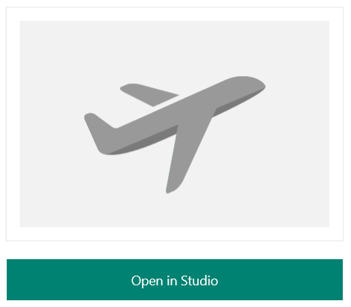

1. When prompted on the next screen, select the **South Central US** region and the workspace you created in Task 1 of Exercise 2.

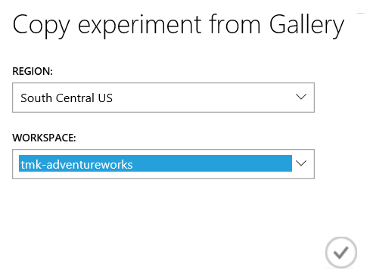

1. After the copy operation finishes, the completed ML experiment will appear in your workspace.

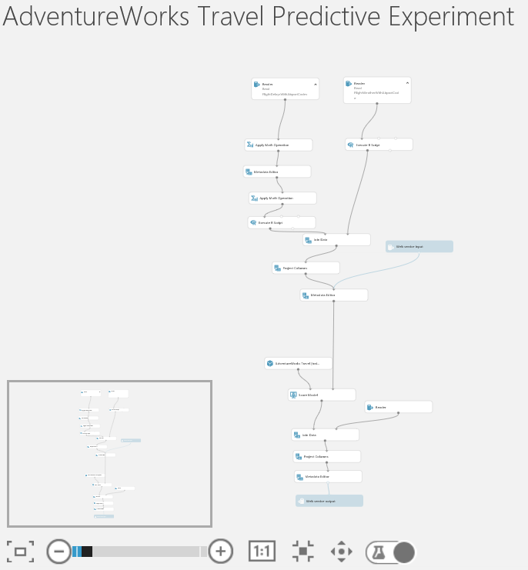

1. Run the experiment. This will take 5-7 minutes.
2. When the experiment is finished running, click **Deploy Web Service**. When the deployment is complete, you will be taken to the Web Service dashboard.

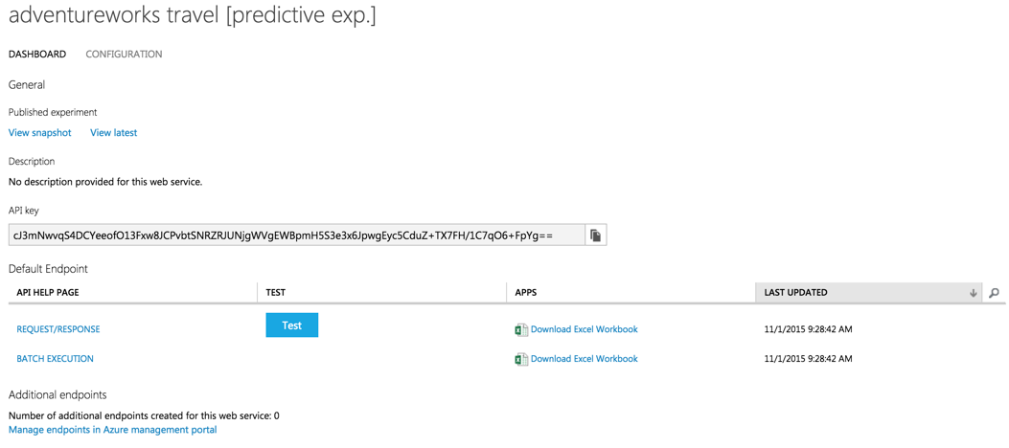

1. At this point, you are now ready to return to and complete Exercise 2. The only task remaining is Task 8.

**Links**

**Create Dev/Lab** <http://bit.ly/2pAsC4n>

**Virtual Machine ID and Password**

|  |  |
| --- | --- |
| ID: | cortana or .\cortana |
| Password: | Password.1!! |

**Down documents/slides** <http://bit.ly/2qtrDHx>